

**UNIVERSITY OF NAIROBI.**

**THE APPLICATION OF GEOSPATIAL TECHNOLOGIES IN SITING OF HEALTH FACILITIES: CASE STUDY, KAJIADO COUNTY.**

**KULUNDU REBECCA SHARON**

**F19/1958/2016.**

A project report submitted to the Department of Geospatial and Space Technology in partial fulfillment of the requirements for the award of the degree of:

**Bachelor of Science in geospatial engineering.**

**FEBRUARY 2021**

# ABSTRACT

Planning the location of healthcare facilities is a very important aspect of ensuring equitable access to healthcare facilities.

Despite the importance of good health and well-being, the country and to be more specific Kajiado County is far from having equitable access to health facilities. The location of these health facilities does not correspond to the needs of the population in Kajiado County.

The existing methods of identifying new locations lack criteria that account for the spatial spread of population making new locations to be identified based on political goodwill.

The overall objective was to use Geospatial technology to determine suitable sites for setting up health facilities in the County. Specifically, it sought to identify criteria that influence the location of a health facility, generation of digital maps showing the existing locations of the healthcare facilities, major roads, rivers, railway lines and towns in Kajiado County.

Finally, using the criteria identified to perform multi-criteria analysis to identify the most optimal locations for new healthcare facilities.

The project utilized available literature for setting location criteria to develop a set of criteria for the location of new healthcare facilities. Also, digital maps depicting the various criteria were generated. The multi-criteria analysis was performed to come up with the most optimal areas to locate new healthcare facilities. Flood analysis was also carried out using a DEM of Kajiado to establish the areas that are susceptible to floods to make sure the sites for the new health care facilities were free from dangers of flooding.

The results showed that the most optimal areas are within the following wards; Kuku, Mosiro, Matapato North, Matapato South, Ewaso Oonkidong’i, Kaputiei North, Rurko, Ildamat, Dalalekutuk, Entonet/ Lenkisim, Mbirikani/ Eselenkei, Oloosirken sholinke and Keekonyonke which are in the northeastern, central and some parts of Southern Kajiado.

It can be concluded that Geospatial technologies, GIS to be specific can be applied in a decision support system for the selection of suitable sites for location of health care facilities in the country and globally which can help curb unplanned growth of the facilities and prevent wastage of resources.

# 

# DEDICATION

This project is dedicated to my Dad, Michael Kulundu Okumba who inspired me and guided me to take up Geospatial Engineering.

# ACKNOWLEDGEMENTS

I would like to thank God for giving me life and showing His grace and mercy upon me. This far I have come its Him.

My special appreciation goes to my supervisor Mr. Livingston Asala who has been a great mentor for me. I would like to thank you for encouraging me in my research. You guided me from the time I began my project and was patient with me through everything. I am also grateful for the advice in terms of formulation of my project idea.

I am particularly grateful for the assistance of Mrs. Regina Ng’ang’a from the department of Geospatial and Space Technology for the technical support that she accorded to me during this period.

I am greatly indebted to my great friend Davis Odera Etyang’ who has been with me since day one. Your efforts in helping me in coming up with ideas and writing will forever be appreciated. Thank you for the motivation.

I wish to thank all my colleagues and classmates specifically Victor Wamwea for offering technical assistance to me a great deal.

A special thanks to my family for being there for me and encouraging me and praying for me. To my Dad, Michael Kulundu, I owe you a great deal for being my pillar of strength. To my Mum, Agnes Kulundu, Sister, Carla Sarah and Brothers, Caleb and Manu, I thank you very much for encouraging me and continued support to me.

You were all part of the cause in making my study a success.

**TABLE OF CONTENTS**

ABSTRACT 2

DEDICATION 3

ACKNOWLEDGEMENTS 4

LIST OF TABLES 8

CHAPTER ONE; INTRODUCTION 9

1.1 Background Information. 9

1.1.1 Overview 9

1.2 Problem Statement. 9

1.3 Objectives. 11

1.3.1 Main objective 11

1.3.2 Specific objectives 11

1.4 Justification of Study. 11

1.5 Scope and limitation. 11

1.5.1 Scope 11

1.5.2 Limitation 12

1.6 Organization of the Report. 12

1.7 Definition of Terms. 13

CHAPTER TWO; LITERATURE REVIEW 14

2.1 Overview of Kenya’s Health Sector. 14

2.1.1 Level 1- Community Facilities; 14

2.1.2 Level 2- Health Dispensaries; 15

2.1.3 Level 3 - Health Centers; 15

2.1.4 Level 4 - County Hospitals; 16

2.1.5 Level 5 - County Referral Hospitals; 16

2.1.6 Level 6 - National Referral Hospitals; 16

2.2 The Healthcare System. 17

2.3 Evaluation Criteria. 18

2.4 Health and Sustainable Development Goals. 20

2.5 Flooding. 22

2.5.1 Flooding analysis 22

CHAPTER THREE; MATERIALS AND METHODS 23

3.1 Study Area. 23

3.2 Data and Data Collection. 24

3.3 Overview of Methodology. 25

3.4 Analysis. 32

3.4.1 Clipping 32

3.4.2 Euclidean Distance 32

3.4.3 Reclassification 33

3.4.3.1 Restriction model 33

3.4.3.2 Suitability model 37

**3.4.3.2.1 The Analytic Hierarchy Process** 37

3.5 Weighted Overlay. 45

3.6 Raster Calculator. 45

3.7 Flood Analysis. 45

CHAPTER FOUR; RESULTS AND DISCUSSIONS 46

4.1 Euclidean Distance Results 46

4.2 Restriction Processs Results 51

4.3 Suitability Process Results 56

4.4 Discussion 66

CHAPTER FIVE; CONCLUSION AND RECOMMENDATIONS 68

5.1 Conclusion. 68

5.2 Recommendations. 68

CHAPTER SIX: REFERENCES 70

**LIST OF FIGURES**

**CHAPTER 3**

Fig. 3. 1 Map showing Kajiado County Administrative Boundaries. 25

Fig. 3. 2 Map showing Roads, Rivers, Towns and Residential Areas for Kajiado County 28

Fig. 3. 3 Map showing the Railway line in Kajiado County 29

Fig. 3. 4 Map showing Secondary Healthcare Facilities in Kajiado County 30

Fig. 3. 5 Map showing the data collected in Kajiado County for analysis 31

Fig. 3. 6 Map showing Kajiado digital elevation model data 32

Fig. 3. 7 Map showing Kajiado Wards Administrative boundaries 33

Fig. 3. 8 Image showing Euclidean distance parameters 34

Fig. 3. 9 Image showing the reclassification of Health Care Facilities in the Restriction model 35

Fig. 3. 10 Image showing the reclassification of Roads in the Restriction model 36

Fig. 3. 11 Image showing the reclassification of Rivers in the Restriction model 36

Fig. 3. 12 Image showing the reclassification of Railway Line in the Restriction model 37

Fig. 3. 13 Image showing a restriction model 38

Fig. 3. 14 Image showing the reclassification of Residential areas in the Suitability model. 43

Fig. 3. 15 Image showing the reclassification of Health care facilities in the Suitability model. 44

Fig. 3. 16 Image showing the reclassification of Roads in the Suitability model. 44

Fig. 3. 17 Image showing the reclassification of Rivers in the Suitability model. 45

Fig. 3. 18 Image showing the reclassification of Railway line in the Suitability model. 45

Fig. 3. 19 Image showing the suitability model 46

Fig. 3. 20 Image showing Kajiado DEM and Optimal areas map overlay model 47

**CHAPTER 4**

Fig. 4. 1 Map showing Secondary Healthcare Facilities Euclidean map 47

Fig. 4. 2 Map showing Railway line Euclidean map 48

Fig. 4. 3 Map showing Residential areas Euclidean map 49

Fig. 4. 4 Map showing Rivers Euclidean map 50

Fig. 4. 5 Map showing Roads Euclidean map 51

Fig. 4. 6 Map showing Healthcare Facilities Restriction map 52

Fig. 4. 7 Map showing Railway line Restriction map 53

Fig. 4. 8 Map showing Rivers Restriction map 54

Fig. 4. 9 Map showing Roads Restriction map 55

Fig. 4. 10 Map showing areas not suitable for locating a health facility 56

Fig. 4. 11 Map showing Healthcare Facilities Suitability map 57

Fig. 4. 12 Map showing Railway Suitability map 58

Fig. 4. 13 Map showing Residential Suitability map 59

Fig. 4. 14 Map showing Rivers Suitability map 60

Fig. 4. 15 Map showing Roads Suitability map 61

Fig. 4. 16 Map showing areas ideal for locating health facilities 62

Fig. 4. 17 Map showing optimal areas for locating a health facility 63

Fig. 4. 18 Map showing Kajiado County digital elevation model 64

Fig. 4. 19 Map showing Kajiado County flood analysis 65

Fig. 4. 20 Map showing the most optimal areas for locating a health facility 66

# LIST OF TABLES

Table 3. 1 Table showing the data used for the methodology and analysis. 27

Table 3. 2 Table Showing Overview of methodology. 28

Table 3. 3 Table showing Pairwise Comparison Matrix. 41

Table 3. 4 Table showing Normalized Pairwise Comparison Matrix. 41

Table 3. 5 Table showing criteria weights 42

Table 3. 6 Table showing Consistency. 42

Table 3. 7 Table showing the random index 43

# CHAPTER ONE; INTRODUCTION

1.1 **Background Information.**

### 1.1.1 Overview

Access to healthcare services is essential for the well-being of humans. Studies have shown that the location of healthcare facilities do not always correspond to the needs of the population in most counties in Kenya. This is because the growth and redistribution of population necessitate not only to upgrade healthcare infrastructure but also properly plan the location of healthcare facilities to reduce inequality in coverage according to the spatial redistribution of population and settlements.

Kajiado County has a population of approximately 1,117,840 people according to the 2019 census (Statistics, 2019)with 344 healthcare facilities in the county (Mariita, 2019)

The existing methods of identifying new locations for healthcare facilities lack objective criteria that account for the spatial spread of settlements and population making the new locations to be identified based on political goodwill. This leads to unplanned growth of facilities and sometimes wastage of resources.

Thus it is important to develop real criteria based on geospatial principles that can be used for the location of new healthcare facilities to provide equitable access to healthcare and reduce inequality in coverage.

This is important because the health status of residents of Kajiado County implies their productivity and development of the County.

## **1.2 Problem Statement.**

Accessibility to healthcare services in Kenya has not been given proper attention resulting in poor healthcare services in counties such as Kajiado.

Kajiado County has a population of roughly over one million people (Statistics, 2019)who access 344 healthcare facilities in the area. Kajiado has 59 Level 4 hospitals and Level 3 hospitals.

This is quite low as compared to their population of 1,117,840 people. More so, these hospitals are not distributed according to the World Health Organization distance criteria of siting a hospital.

Most patients die in Kajiado as they are being transported to a better healthcare facility or because of lack of oxygen or accidents in the ambulance on their way to access better healthcare, as most of the healthcare facilities are Level 1 and Level 2.

Although money is budgeted each year for healthcare in Kenya through the Ministry of Health, the problem of inadequate funding and excessive administrative and other problems that delay progress in the building of more hospitals has meant that the total demand for healthcare facilities has always outstripped the supply. For example, in 2017, three children aged between five and eleven were stranded at home after they were allegedly denied medical attention at a private hospital in Kitengela. The minors were run over by a lorry while they played outside their home and while the facility is said to have offered first aid, it turned them away for lack of funds for further medical care (NTV, 2017).

Also another case of a 22-year old woman Ntaise Lessir who lost her life after falling from a moving ambulance along the Kajiado - Namanga road on her way to Kajiado County Referral hospital (Citizen TV, 2020)

Also last year, police in Kajiado County were investigating the circumstances under which an expectant woman and her 2-year-old son met their death while being transferred from one health facility to another. The expectant woman plunged to her death from a moving ambulance after her son’s condition deteriorated (Citizen Tv, 2020).

All this is to show how the demand for healthcare facilities has outstripped the quality and the supply of healthcare.

But apart from the qualitative and quantitative shortage in the provision of healthcare services in the Country and Kajiado County, the few available facilities in Kajiado County are not efficiently distributed within the population it is meant to serve with the effect that some parts of Kajiado population are deprived of access to this important public service leading to unexpected deaths that could have been avoided.

In Kenya, Level 3 and Level 4 hospitals are categorized as secondary healthcare facilities according to the Ministry of Health. There is need to set up these new health care facilities by siting them and identifying the best site for the hospitals according to the WHO distance criteria.

The North-Eastern part of Kajiado is the only part with a moderate to a high number of healthcare facilities thus there is need for equitable distribution of these healthcare facilities in the rest of the county.

## **1.3 Objectives.**

### 1.3.1 Main objective

To use Geospatial Technology to determine suitable sites for setting up health facilities in Kajiado county.

### 1.3.2 Specific objectives

1. Identify the factors that influence the location of a health facility.

2. Generation of digital maps depicting the various criteria for the location of a health facility.

3. Performing multi-criteria analysis using the criteria that influence the location of a healthcare facility to determine the most optimal areas for the location of new health care facilities.

## **1.4 Justification of Study.**

Explicit consideration has not been given to the need for equitable siting and distribution of healthcare facilities in Kajiado County according to the World Health Organization.

The WHO distance criteria attempt to explain the ideal distance that a patient can travel to access healthcare.

This attempt to site the location of the new healthcare facilities according to the WHO distance criteria requires the use of a Geographic Information System to improve the accessibility of healthcare facilities and propose their location.

## **1.5 Scope and limitation.**

### 1.5.1 Scope

The study area is Kajiado County, level 4 hospitals majorly but not limited to that; other types of health facilities are also covered.

The scope of study included downloading data from open street maps and sorting out the data. Also, sorting out healthcare facilities data of Kajiado County only and singling out only Level 3 and Level 4 hospitals.

Also research for the World Health Organization distance criteria on the allocation of a health facility was done by visiting their offices and the Ministry of Health offices.

Weighted overlay of the residential areas, rivers, roads, railways and the existing healthcare facilities was calculated using the Analytical hierarchy process.

Generation of restriction maps,suitability maps and finally maps showing the most suitable areas for locating a healthcare facility using ArcGIS was done.

### 1.5.2 Limitation

Some hospitals are way too rural to access their coordinates thus necessitating polar computation which is tedious and time-consuming.

## **1.6 Organization of the Report.**

The report is divided into 5 chapters.

**i. Chapter 1: Introduction**

This chapter contains an introductory part, background, problem statement, objectives, scope, and limitations of the study and organization of the report.

**ii. Chapter 2: Literature Review**

This chapter outlines the relevant literature and the recent works related to the study.

**iii. Chapter 3: Materials and Methods**

The study parameters, data sources, data preparation criteria and test methods employed are discussed.

**iv. Chapter 4: Results and Discussions**

This chapter shows the results that were obtained for the operations that were carried out and a discussion of the results.

**v. Chapter 5: Conclusions and Recommendations**

Necessary conclusions and recommendations are given as per the results obtained.

## **1.7 Definition of Terms.**

**i. Health**

Health can be defined as physical, mental and social well-being and as a resource for living a full life. It refers not only to the absence of disease but the ability to recover and bounce back from illness and other problems.

**ii. Health facility**

A health facility is a place that provides healthcare. They include hospitals, clinics, outpatient care centers, specialized care centers such as birthing centers, psychiatric care centers, etc.

**iii. Clinic**

Is a healthcare facility that is primarily focused on the care of outpatients where they are given medical advice or treatment especially by a specialist nature.

**iv. Dispensary**

A dispensary is an office in a school, hospital, industrial plant, or other organization that dispenses medication, medical supplies, and in some cases even medical and dental treatment.

**v. Hospital**

Is a healthcare institution providing patient treatment with specialized medical and nursing staff and medical equipment?

**vi. Nursing home**

Is a small private institution providing residential accommodation with healthcare, especially for elderly people**.**

**vii. Primary healthcare hospital**

Is nothing but the hospital with the network of your health insurance policy coverage that you can visit anytime without taking any permission from your insurer.

# CHAPTER TWO; LITERATURE REVIEW

## **2.1 Overview of Kenya’s Health Sector.**

To properly identify suitable areas for the location of health facilities, there is need to understand the Health system structure in Kenya.

Kenya's Health sector is one of the 14 devolved functions managed by the 47 county governments as provided in the Fourth Schedule of the 2010 Constitution.

County health facilities and pharmacies, ambulance services, promoting primary health care, licensing, and controlling facilities that sell food to the public and veterinary services are some of the health-related roles the 47 counties manage.

County health facilities and services include county referral hospitals, sub-county health facilities, environmental health services, communicable disease control, nutrition, family planning, maternal and child health plus Health Education.

There are six different levels of health care facilities. The first five are managed on the county level, the sixth level by the national government.

In this system, the patients may move from one level to the next by using a referral letter (Mariita, 2019)

### 2.1.1 Level 1- Community Facilities;

They are run by certified medical clinical officers

Some of the services:

* Treatment of minor ailments like diarrhea.
* Tuberculosis (TB) screening, home visits, contact tracing of TB patients and tracing of TB defaulters.
* Screening of malnutrition.
* Malaria rapid test.
* Blood pressure and blood sugar testing.
* HIV testing.
* Health talks with pregnant women and observations of signs of danger.
* Issuance of referral letters to other facilities

### 2.1.2 Level 2- Health Dispensaries;

These facilities are run by clinical officers.

The dispensaries in the cities act as a health center (see level 3), with the difference that the dispensary does not have in-patient facilities.

These are some of the services you will expect in a dispensary:

* Outpatient services.
* VCT services.
* Tuberculosis services.
* Laboratory Services.
* Well baby Clinics.
* Antenatal and Postnatal services.
* Pharmacy.
* Counselling services.
* Curative treatment.
* They issue referral letters to other facilities.

### 2.1.3 Level 3 - Health Centers;

These are small hospitals with minimal facilities, yet they offer services like the big hospitals. They are run by at least one doctor, clinical officers and nurses.

These are some of the services they offer:

* Maternity in-patient services with a ward.
* Curative services.
* Laboratory services.
* Dental.
* Counselling.
* Pharmacy.
* TB Clinics.
* Diabetes & hypertension clinics.
* Comprehensive care clinics for patients living with HIV.
* Baby well clinics.
* Antenatal and postnatal services.
* They issue referral letters to other facilities.

### 2.1.4 Level 4 - County Hospitals;

These are hospitals that offer holistic services and are run by a director who is a medic and at best a doctor by profession.

In many counties, there's just one hospital but in larger cities like Nairobi, there are two.

They have in principle the same services as the Level 3 hospitals, plus X-Ray services.

They issue referral letters to other facilities.

### 2.1.5 Level 5 - County Referral Hospitals;

These are the county referral hospitals formerly the provincial hospitals.

They are run by Chief Executive Officers who are medic by profession and have over 100 beds capacity for their in-patient. They are also doing research about health.

In Nairobi Mama Lucy Hospital and Mbagathi Hospital both double up as county referral hospitals and Level 4 hospitals.

Services include what other hospitals offer, plus:

* Ultrasound.
* CT-Scan.
* Surgery.
* Pharmacy.
* Physiotherapy.
* Orthopedics.
* Occupational Therapy.
* They issue referral letters to other facilities.

### 2.1.6 Level 6 - National Referral Hospitals;

In Kenya, there are three Teaching and Research referral hospitals: Mathare Hospital, Kenyatta National Hospital, Moi Teaching and Referral Hospital, and the National Spinal Injury Referral Hospital.

Their range of services is the same as on Level 5, but they offer specialized treatments to patients and are not only accessed by Kenyans but do serve East Africa and Central Africa.

* Mathare Teaching and Referral Hospital offers specialized mental services.
* Kenyatta National Hospital and Moi Teaching and Referral hospital offer specialized consultations in curative care.
* National Spinal Injury Referral offers specialized services in orthopaedical and spinal injuries.

The national government manages these three hospitals.

**2.2 The Healthcare System**.

According to the Kenya Ministry of Health, Level 1 and Level 2 hospitals are classified as primary healthcare facilities. Level 3 and 4 are classified as secondary healthcare facilities and Level 5 and 6 are classified as tertiary healthcare facilities.

The government health service is supplemented by privately owned and operated hospitals and clinics and faith-based organizations’ hospitals and clinics, which together provide between 30 and 40 percent of the hospital beds in Kenya.

The importance of an effective and accessible healthcare system in any country cannot be overemphasized.

However, due to high demand for and perhaps poor quality delivery of service by the Kenyan public hospitals, the private sector is playing a major role in the provision of healthcare in Kajiado County. While the private sector is driven primarily by economic considerations in their location decisions, the public sector is apparently concerned with maximizing access of the target population to the facilities.

Given the importance of healthcare services to any society, the enormous amount of money expended on its provision yearly and the impact of accessibility to its utilization, it’s important to ask, therefore: how do public decision-makers determine the efficient location points for health facilities to maximize accessibility as well as utilization? Suggesting a solution to the above question is what forms this paper.

Among the many tools for solving spatial location problems, the capability of Geographical Information Systems in spatial planning and management has been acknowledged. A Geographic Information System is a technical software designed to accept, analyze, store and output geo-based data. Geographical Information System has been applied in different geo-location, visualization, and numerous decision support context.

In the last few decades, GIS application in healthcare facility and services management has become widespread and indispensable.

As far back as 1854, Johnsnow made one of the foremost applications of GIS to health mapping. He used GIS to map disease outbreaks in Broad Street, USA and was able to trace their cause and source (Fine, 2013). Since then, GIS has been of tremendous help and support in health facility location, mapping analysis and services demand forecast.

In Kenya, (Kavuwa, 2010)developed a Web-GIS for Health Management Information System for Buruburu that provides information about health services, facility location and other health-related information which enabled patients to make decisions about their healthcare and that of their families.

Given the importance of healthcare delivery in any society and the government effort to raise the quality of life of its citizens through healthcare provisions in Kajiado County, it becomes important to evaluate the efficiency of the current locational pattern of available healthcare facilities in Kajiado County to ensure efficiency and maximum possible utilization. Consequently, following WHO's (1997) recommendation for health facility planning in developing economies, this project aimed at evaluating the efficiency of healthcare facilities location in Kajiado County in order to propose new locations of the facilities in the area.

To achieve that, there was need to:

- analyze the location of the existing healthcare facilities in Kajiado County.

- suggest the efficient and equitable locations of healthcare facilities in Kajiado County using WHO distance criteria.

## **2.3 Evaluation Criteria.**

In the spatial context, evaluation criteria are associated with geographical entities and relationships between entities and can be represented in the form of maps. A criterion map models the preference of the decision-maker concerning a particular concept, while a simple map layer is a representation of some spatial real data.

A criterion map represents subjective preferential information.

Two different persons may assign different values to the same mapping unit in the criterion map (Keenan, 1997)

Secondary health care facilities which comprise Level 3 and Level 4 hospitals according to the Kenya Ministry of Health were used as the case study for this research to determine the optimal location areas for new secondary healthcare facilities following World Health Organization (1997) recommendation for health facility planning in developing economies (Fadahunsi, 2017) (Njoku, 2013) and World Health Organization(1996) guidelines for development of hospials (Mrs P.C. Luis, 1996).

The criteria were as follows;

1. The minimum distance between two secondary healthcare facilities should be 500m and a maximum distance of 10km.

Kajiado County has 60 secondary healthcare facilities. Any health facility located less than 500m from each other causes overcrowding of the health facilities and health facilities located more than 10km from another is not ideal for a patient seeking treatment and one might die on their way to the hospital.

2. A healthcare facility should be within 5km of a residential area.

These residential areas comprise of towns, settlements,and schools. Someone can fall sick easily or need emergency medical attention thus it’s only ideal that a healthcare facility is located within 5km of a residential area.

3. A healthcare facility should be more than 45m offset from a major road.

This is because a road might need expansion and a healthcare facility is on the way thus it has to be more than 45m offset a major road.

Also, a healthcare facility should be more than 45m from a major road for patients to be easily rushed to a hospital and in case one falls ill on the road or while travelling.

4. A healthcare facility should be more than 45m offset from a railway line.

This is to avoid an accident in case the train breaks and rams into the hospital building. Also, it can facilitate faster medical attention for patients travelling by train.

It can also aid in the transportation of heavier medical equipment.

5. A healthcare facility should be more than 45m from a major river.

This is to enable the supply of water to the healthcare facilities as hospitals need water for cleaning and just to manage other important things.

This is also to prevent calamities in case of flooding as the healthcare facilities can be swept away in the event of such and cause casualties.

Also, this is to prevent pollution of the water sources with wastes from the healthcare facilities.

6. A healthcare facility should be located in an area that is free from the dangers of flooding. It must therefore not be located at the lowest point in an area.

## **2.4 Health and Sustainable Development Goals.**

The 2030 agenda for sustainable development outlines a transformative vision with 17 sustainable development goals for economic, social and environmental development.

Matters to do with health are encompassed within the Sustainable Development Goals through Goal 3 whose goal is to Ensure healthy lives and promote well-being for all at all ages

Intersectoral governance is at the core of how to approach the social determinants of health, and how to address antimicrobial resistance through a one health approach.

More specifically, to achieve universal health coverage, Member States must ensure access to health services by introducing protection against catastrophic health expenditure. Obstacles and financial hardships associated with weak health systems and inadequate financing mechanisms not only exacerbate health inequities, but also jeopardize the achievement of other SDGs.

Universal health coverage could therefore contribute to achieving the SDGs by producing equitable and sustainable health outcomes. Many health disparities between people with different socioeconomic statuses are compounded by gaps in good governance.

For instance, corruption makes access to health services, medication and information much more difficult for the vulnerable. Besides, factors such as ethnicity, gender and disability can further exacerbate these health disparities. Hence, tracking indicators that measure the health of vulnerable groups are essential.

Monitoring the status of equitable access to health care could also shed light on the status of human rights and social equality within states. Those people not receiving adequate health services are probably also disadvantaged in other social aspects. A better understanding of factors contributing to access to health services will help shape policies to attain SDG 3, and support the achievement of other SDGs such as attaining gender equality, reducing poverty and improving education.

Currently, robust data on health-related targets and indicators are lacking in many countries; developing better implementation and measurement tools, and linking data across sectors is a cornerstone of the SDGs and should be a priority in global health policy dialogue.

The 2030 agenda also emphasizes the environmental determinants of health. The 2016 World Health Organization report preventing disease through healthy environments estimated that 23% of all deaths could be attributed to environmental issues such as air pollution, poor sanitation, exposure to radiation and other environment-related causes. Progress on the SDGs that target environmental improvements will also improve health indicators.

Health has a central position in the agenda through SDG 3 and is closely linked to over a dozen targets in other goals related to urban health, equal access to treatments, and non-communicable diseases.

For example;

Better education for girls in Kajiado County would improve maternal healthcare.

Tackling child malnourishment would have a great impact on child health.

Ensuring access to safe water prevents people from contracting diseases thus promoting better health.

Tackling air pollution will improve health as it prevents people from contracting respiratory illnesses.

Clean energy, using more renewable sources of energy rather than something like coal which has a negative impact on health.(Shambhu Acharya, 2018)

## **2.5 Flooding.**

In another research (Mrs P.C. Luis, 1996) under factors to consider when locating a hospital, siting a hospital in an area that is free from the dangers of flooding was one of the criteria.

The terrain of Kajiado County encourages flooding as many cases of flooding have been reported. For example, on November 25th, 2019, five family members were killed after their vehicle was swept away by flash floods at Ngatatoek area in Kajiado Central (Masi, 2019). Also, on 28th December 2019, more than 300 people were displaced from their homes in Kajiado County after heavy rains flooded their homes in Olkiramatian area of Magadi Ward. (Marindany, 2019) Therefore, there’s need to locate hospitals in this county in areas that are free from the dangers of flooding.

In order to effectively site the most optimal areas for locating a healthcare facility in Kajiado County, flood analysis had to be done.

### 2.5.1 Flooding analysis

Floods can be mitigated by conducting a vulnerability analysis where flood mapping can be done to establish places that are susceptible to flooding. One of the ways to do this is through the use of Geographic Information Systems where Remote Sensing plays a crucial role. Digital Elevation Model data can be used to extract the cross-section of flood plains that can further give information on the flood plain elevations and their boundaries (Shamshi, 2012)Satellite technology on the other hand is an important tool in monitoring the flooding phenomena and its extent on the land surface. From this flood risk maps can be created to investigate the risk such waters may cause to human settlements. Also, maps delineating the flood-prone areas can be created.

In this research, flood analysis was done to establish potential flood prone areas as a healthcare facility should be located in an area that is free from the dangers of flooding.

Such areas may not be suitable for siting of healthcare facilities as their accessibility would be cut off from the residents.

# CHAPTER THREE; MATERIALS AND METHODS

## **3.1 Study Area.**

Kajiado County is located in the southern region of Kenya about 108.3 km from Nairobi. It is bordered by Nairobi County, Machakos County, Kiambu County and Nakuru County at the top.

It is divided into five sub-counties namely Kajiado North, Kajiado West, Kajiado Central, Kajiado South and Kajiado East.

Kajiado has a population of around 1,117,840 people. It is located 2.09810 south of the equator and 36.78200 east of the Greenwich meridian.

Kajiado has an area of 21,871.1km2.

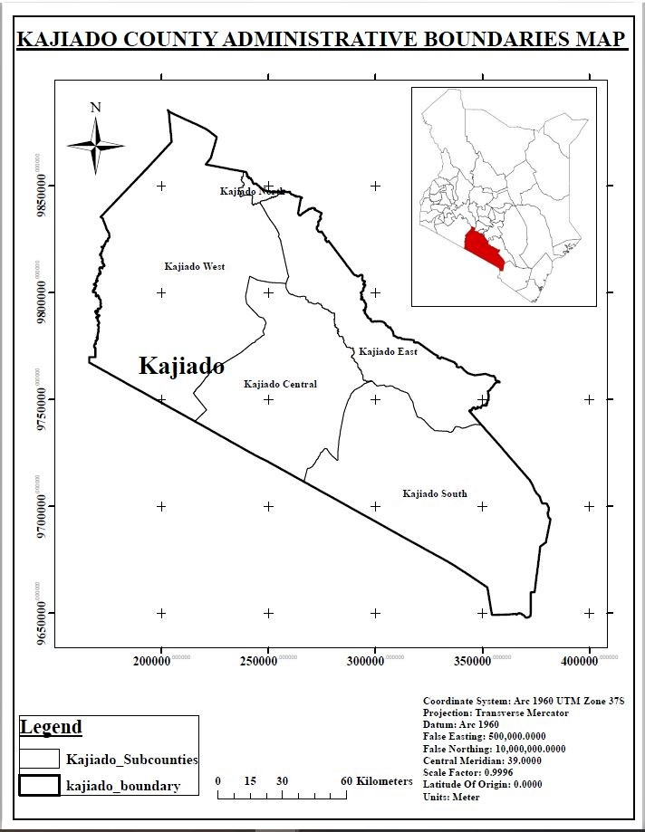

Fig. 3. 1 Map showing Kajiado County Administrative Boundaries.

## **3.2 Data and Data Collection.**

The data used for the methodology and analysis were as follows.

|  |  |  |  |
| --- | --- | --- | --- |
| Data | Data Source | Date of data acquisition | Description of data |
| Kenya Administrative Boundaries | IEBC through Humanitarian data exchange | 20th February 2020 | Level 1 |
| Shape Files | Open street maps. | Wednesday, November 25th UTC 2020 | Datum was 1984 |
| Health Facilities in Kenya | Esri’s ArcGIS Feature Service | 3rd April 2019 | Point layer excel file |
| Keyhole Mark up Language File (KML) | Google Earth Pro | 13th December 2020 | Universal transverse Mercator map projection |
| Kenya SRTM 30m | RCMRD Geoportal | 17th January 2021 | Elevation Raster dataset from Shutter Radar. |
| Kenya Wards Boundaries | IEBC through Humanitarian data exchange | 9th February 2021 | Elections geodata shapefile |

Table 3. 1 Table showing the data used for the methodology and analysis.

Software used; ArcGIS version 10.6

**3.3 Overview of Methodology.**

It comprises the following layers; secondary healthcare facilities, major roads, major rivers, railway lines, residential areas.

DATA COLLECTION

DATA IDENTIFICATION

Secondary healthcare facilities, major roads, major rivers, railway lines, residential areas, Kenya SRTM 30m.

CLIPPING

Clipped Kenya SRTM 30 metres (Kajiado DEM)

Clipped roads

Clipped residential areas

Clipped railway line

Clipped healthcare facilities

Clipped rivers

Spatial analysis using Euclideandistance

Residential areas Euclidean

Healthcare facilities Euclidean

Rivers Euclidean

Roads Euclidean

Railway line Euclidean

Reclassification

Reclassified roads

Reclassified rivers

Reclassified healthcare facilities

Reclassified residential areas

Reclassified railway line

Raster calculator Weighted overlay

Suitability map

Restriction map

Raster calculator (Times)

Optimal areas for locating a health facility

Kajiado DEM

Rastor calculator (Times)

Most optimal areas for locating a healthcare facility

Table 3. 2 Table Showing Overview of methodology.

**Kenya Administrative Boundaries;**

The data for Kenya administrative boundaries was downloaded to extract Kajiado County administrative boundaries and the sub-counties' boundaries. See Fig.3.1 above.

**Shape File Data;**

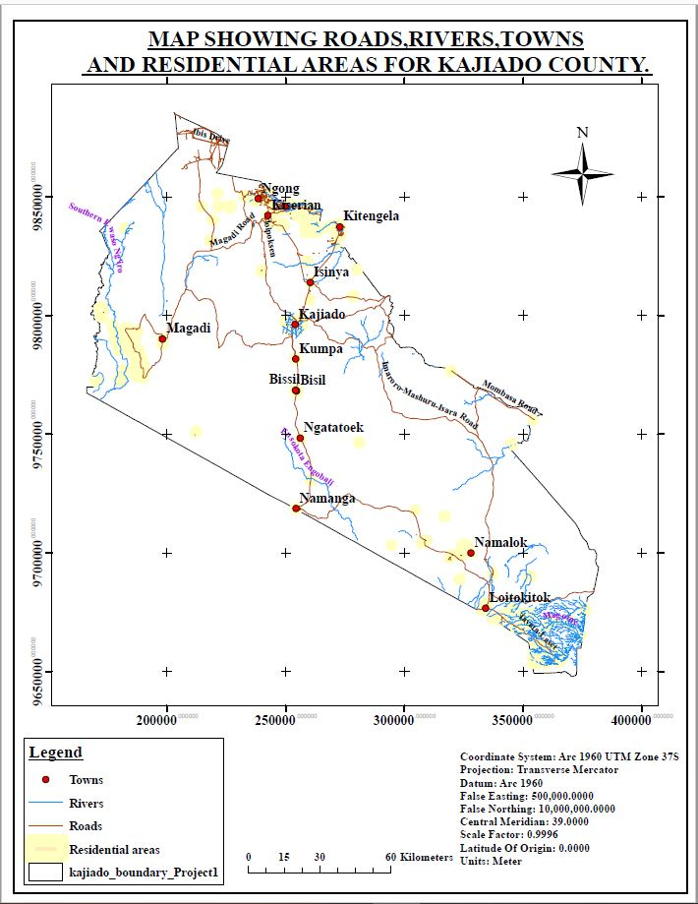The shapefile data was extracted from Open Street maps to extract roads, rivers, towns and residential areas for Kajiado County.

Fig. 3. 2 Map showing Roads, Rivers, Towns and Residential Areas for Kajiado County

**KML Files;**

The KML file were extracted from google earth pro to extract the railway line.

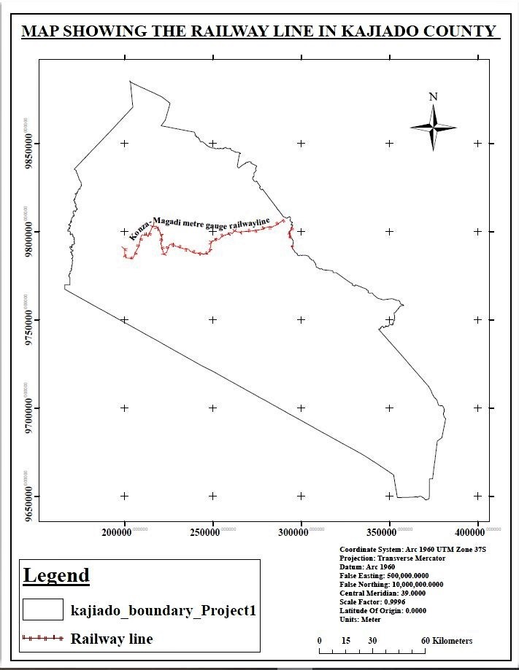

Fig. 3. 3 Map showing the Railway line in Kajiado County

**Health facilities in Kenya;**

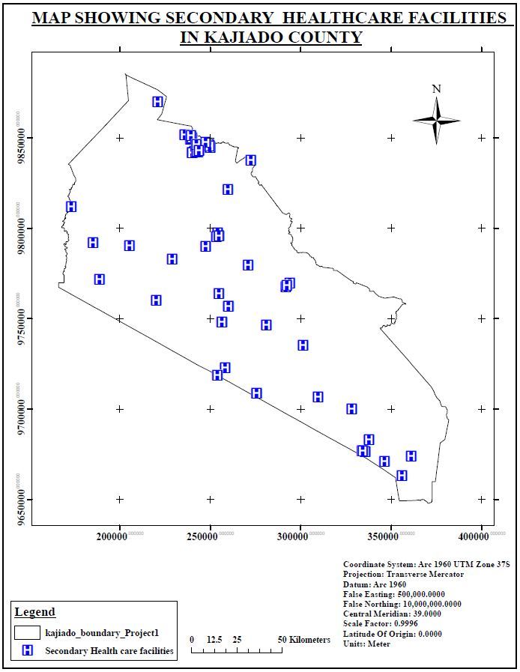Health facilities were extracted from Esri’s feature service together with their coordinates for Kajiado County. Level 3 and Level 4 healthcare facilities were extracted from this excel file.

Fig. 3. 4 Map showing Secondary Healthcare Facilities in Kajiado County

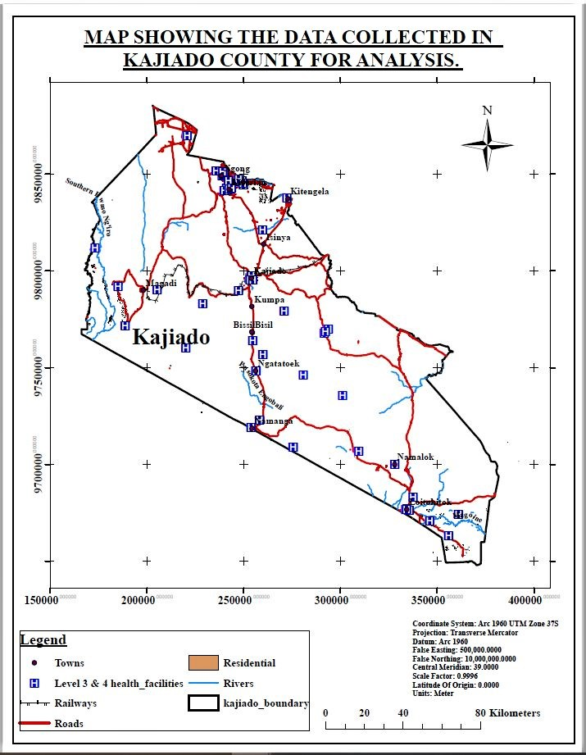

Fig. 3. 5 Map showing the data collected in Kajiado County for analysis

**Kenya SRTM 30 Meters;**

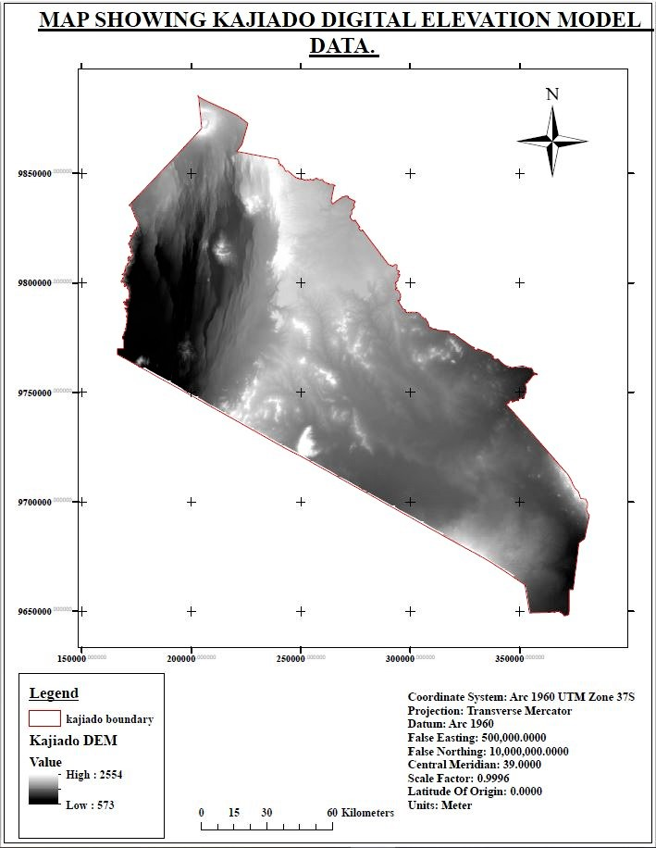The Kenya SRTM elevation raster dataset was obtained from the RCMRD geoportal and clipped to Kajiado County. Its purpose was to perform a Flood analysis in Kajiado county to further help in the identification of the most optimal areas for the location of health facilities.

Fig. 3. 6 Map showing Kajiado digital elevation model data

**Kenya Ward Boundaries;**

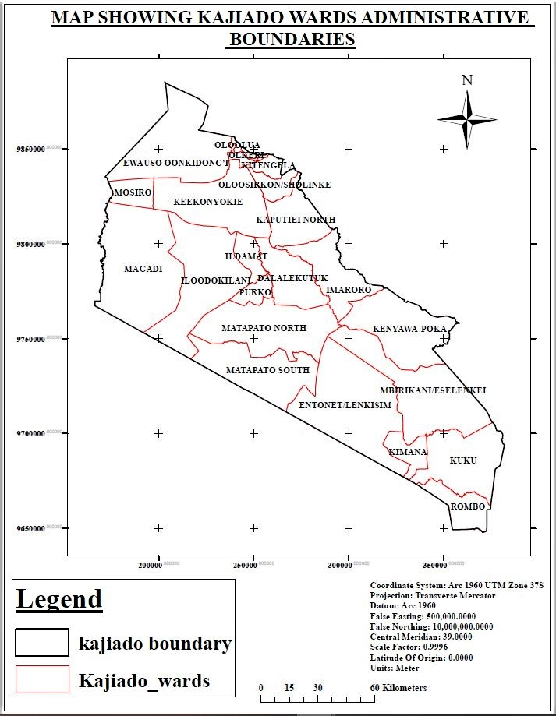The Kenya Ward Boundaries were obtained from the IEBC through Humanitarian data exchange in order to extract Kajiado ward boundaries.

Fig. 3. 7 Map showing Kajiado Wards Administrative boundaries

**Criteria Used for Determination of Optimal Areas for Locating a Healthcare Facility**

i. The minimum distance between two secondary healthcare facilities should be 500m and maximum distance 10km.

ii. A healthcare facility should be within 5km of a residential area.

iii. A healthcare facility should be more than 45m offset from a major road.

iv. A healthcare facility should be more than 45m offset from a railway line.

v. A healthcare facility should be more than 45m from a major river.

vi. A healthcare facility should be located in an area that is free from the dangers of flooding. It must therefore be located at the lowest point in an area.

## **3.4 Analysis.**

### 3.4.1 Clipping

The clip is a tool in ArcGIS software used during analysis to extract input features that overlay the clip features. The input features to clip can be points, lines or polygons.

All the datasets in this research were clipped using Kajiado County administrative boundary to obtain the data within the area of study. The data result from the clip was for major roads, rivers, residential areas and healthcare facilities in Kajiado County.

The railway line was digitized from Google Earth pro for the study area.

### 3.4.2 Euclidean Distance

Euclidean distance was calculated for the roads, rivers, railways, health centers and residential areas datasets in Kajiado County at unspecified distances as they would later be reclassified. Essentially, through this, the vector datasets were converted into raster datasets.

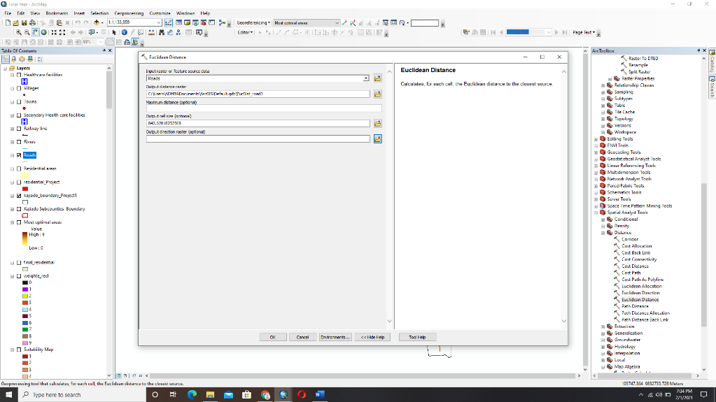

Fig. 3. 8 Image showing Euclidean distance parameters

### 3.4.3 Reclassification

Reclassification is the process of re-assigning one or more values in a raster dataset to new output values. Reclassification can be done to one value or a group of values using fields such as specified intervals. Therefore, many values on an input raster can be changed to specified alternative values. Reclassification is done using the Reclassify tool in spatial analyst using ArcGIS software.

Euclidean distance generated continuous raster datasets for each of the Input Vector datasets. To simplify the information from the Euclidean distance raster, reclassification is necessary. This is done by grouping the raster values within certain ranges that are easily interpreted.

For the Euclidean raster datasets, they were reclassified and their old raster values were given new values.

Reclassification was done for both the Restriction model and the suitability model.

#### 3.4.3.1 Restriction model

Under the restriction analysis, the reclassification was done following the laid out criteria for the location of health facilities. For existing healthcare centers, values from 0 to 500m were given a new value 0 and any value above 500 was given value 1.

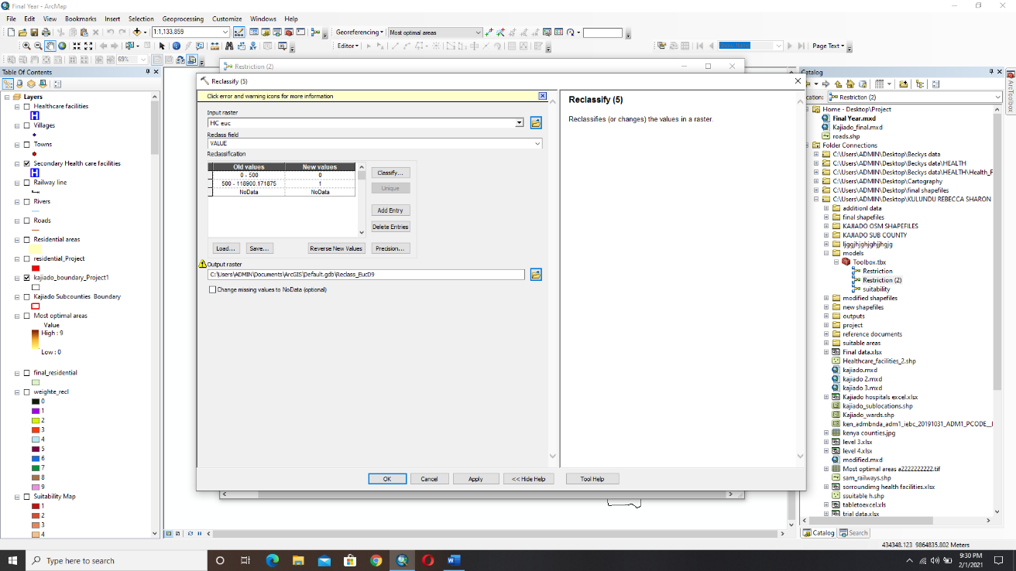This meant that any distance 500m from a health facility is restricted from setting a new healthcare facility but a healthcare facility can be constructed at any distance above 500m.

Fig. 3. 9 Image showing the reclassification of Health Care Facilities in the Restriction model

For roads, rivers and railways, their criteria state that a healthcare facility should be more than 45m offset a major road, river or railway line.

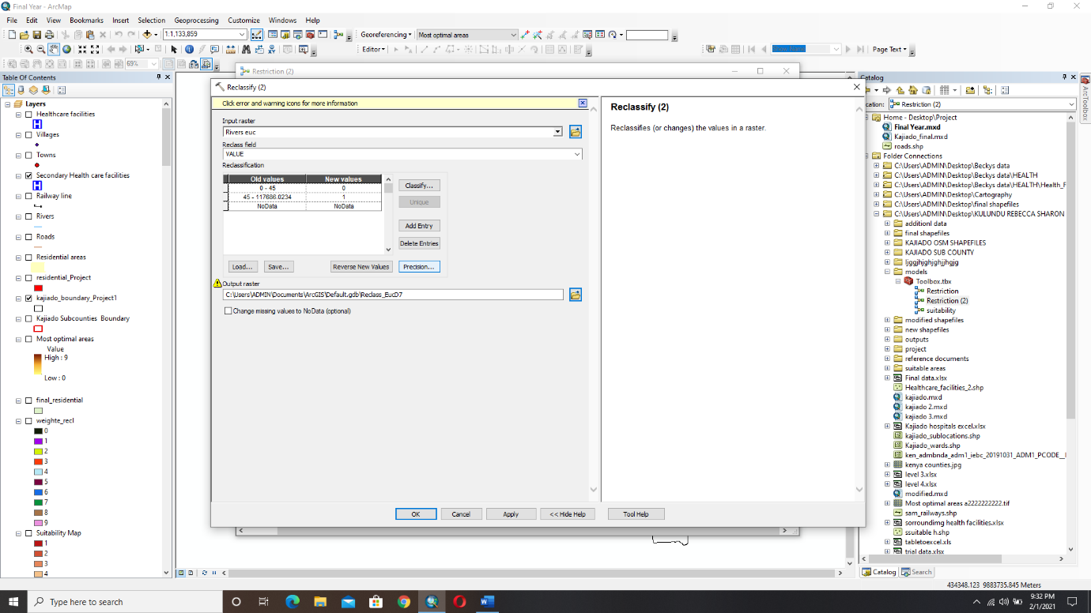Therefore values from 0 to 45m were given a new value 0 and any distance above 45m was given a new value 1. This means that any distance from 0 to 45m is restricted from setting up a new healthcare facility while any distance above 45m is suitable to set up a healthcare facility.

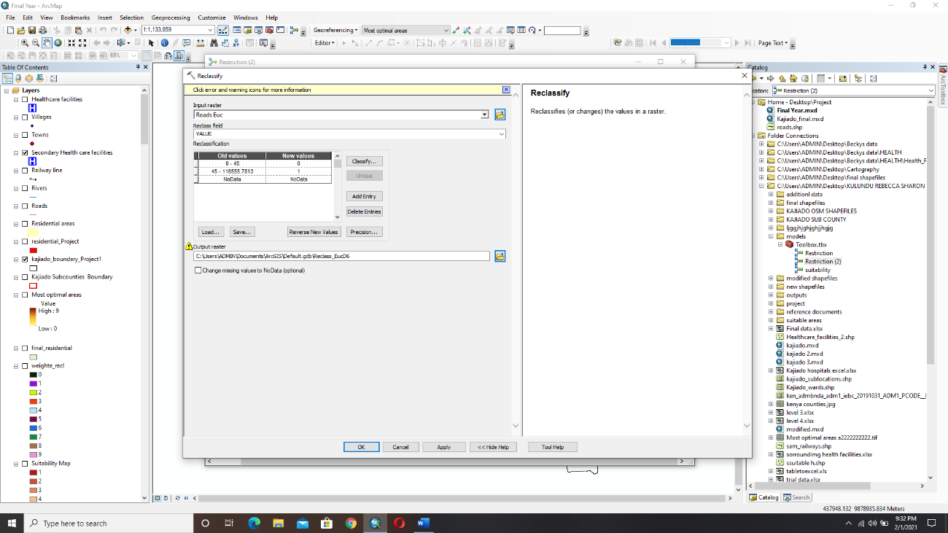Fig. 3. 10 Image showing the reclassification of Roads in the Restriction model

Fig. 3. 11 Image showing the reclassification of Rivers in the Restriction model

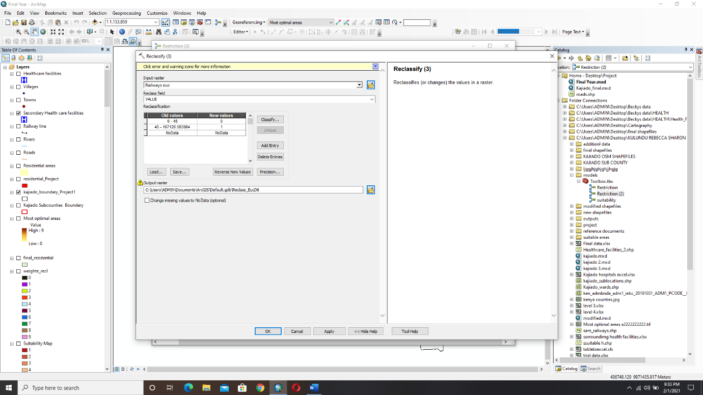

Fig. 3. 12 Image showing the reclassification of Railway Line in the Restriction model

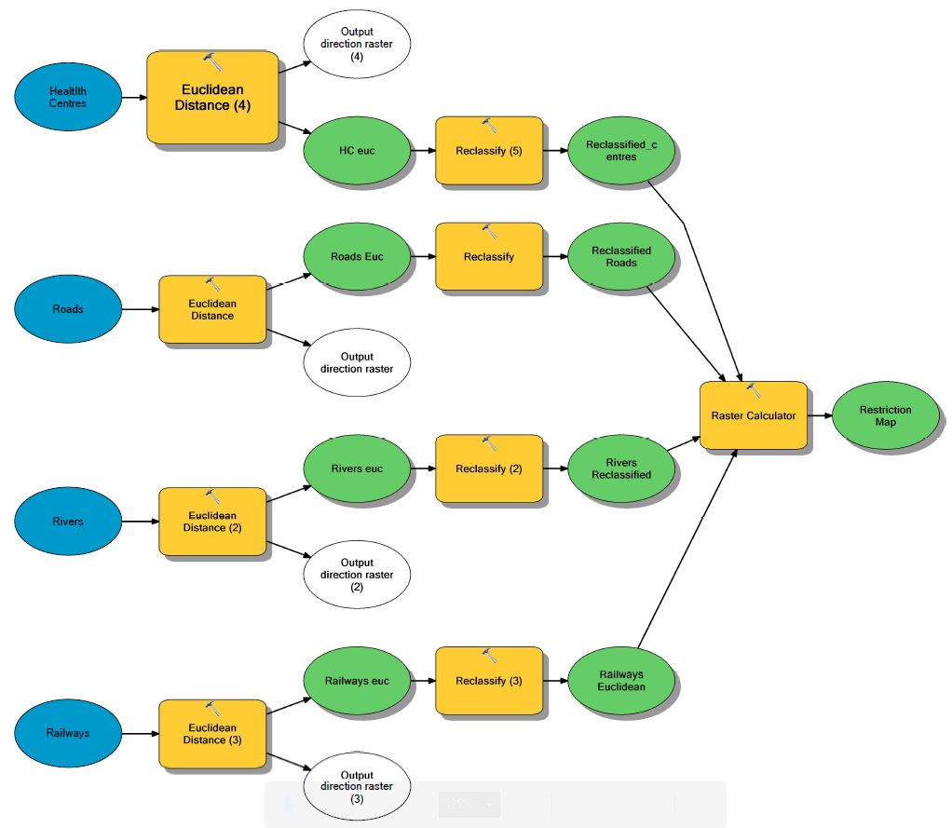Fig. 3. 13 Image showing a restriction model

Under the restriction model, we did not include the residential areas as the criteria state that the healthcare facilities should be within 5km of a residential area. There is no restriction distance given for the location of the health facility but just 5km distance.Overlaying the reclassified roads ,rivers,railwayline and existing healthcare facilities through a rastor calculators resulted in the generation of a restriction map.

#### 3.4.3.2 Suitability model

The relative importance of the datasets in locating the most suitable areas was weighted through a process known as analytic hierarchy process.

##### **3.4.3.2.1 The Analytic Hierarchy Process**

This is a method used to organize and analyze complex decisions using math and psychology. It was developed by Thomas L. Saaty in the 1970s and has been refined since then.

It contains three parts; the ultimate goal or problem; one is trying to solve, all of the possible solutions, called alternatives and the criteria you will judge the alternatives on.

Analytic Hierarchy Process provides a rational framework for a needed decision by quantifying its criteria and alternative options and for relating those elements to the overall goal. Stakeholders compare the importance of criteria, two at a time, through pair-wise comparisons. (Technology, 2014).

A weighting criterion was applied for the six criterion based on the importance of each of them with regard to identification of optimal areas for location of a health care facility.

The biggest priority was given to residential areas as all the other criterias can fall within residential areas.A road , river , railwayline or healthcare facility can be located within a residential area.Also these are places where people work and live and they might need urgent medical attention . This was followed by health centers to avoid the congestion of health centers, and then by roads as someone can fall ill while travelling on the road or in case of a road accident. Roads were followed by rivers and lastly railways.This was done after consultation with experts from the Ministry of Health.

**Step 1;**

**Pairwise Comparison Matrix**

Pairwise comparison is any process comparing entities in pairs to judge which of each entity is preferred or has a greater amount of the same quantitative property or whether or not the two entities are identical.

Each cell in the matrix corresponds to a comparison of a pair of items. The cells will contain the item that is considered the most important of the pair.

A pairwise comparison matrix is created with the help of a scale of relative importance developed by Saaty as follows;

1. Equal Importance.

3 Moderate Importance.

1. Strong Importance.

7 Very Strong Importance.

1. Extreme Importance.

2, 4, 6, 8 Intermediate values.

$1/3$, $1/5$, $1/7$, $1/9$ Values for inverse comparison.

The importance of residential areas in locating a health facility as compared to other residential areas are of equal importance hence value 1.

The importance of residential areas as compared to roads in locating a health facility is of equal to moderate importance hence value two (2).

The importance of residential areas as compared to railways line in locating a health center is Very Strong Importance thus the value 7.

In that order. After that, the sum of each value in the column was calculated

**Pairwise Comparison Matrix**

|  |  |  |  |  |  |
| --- | --- | --- | --- | --- | --- |
|  | Residential | Roads | Railway | Waterway | Existing Health care facilities |
| Residential | 1 | 2 | 7 | 5 | 2 |
| Roads | $$1/2$$ 0.5 | 1 | 5 | 4 | $$1/2$$ 0.5 |
| Railway | $$1/7$$ 0.1429 | $$1/5$$ 0.2 | 1 | $$1/4$$ 0.25 | $$1/5$$ 0.2 |
| Waterway | $$1/5$$ 0.2 | $$1/4$$ 0.25 | 4 | 1 | $$1/4$$ 0.25 |
| Existing Health care facilities | $$1/2$$ 0.5 | 2 | 5 | 4 | 1 |
| Sum | 2.3429 | 5.45 | 22 | 14.25 | 3.95 |

Table 3. 3 Table showing Pairwise Comparison Matrix.

In this table, row elements were divided by column element i.e. in Row 1

**Step 2**

**Normalized Pairwise Comparison Matrix**

|  |  |  |  |  |  |  |
| --- | --- | --- | --- | --- | --- | --- |
|  | Residential | Roads | Railway | Waterway | Existing Health care facilities | Criteria Weights |
| Residential | 0.4268 | 0.3670 | 0.3182 | 0.3509 | 0.5063 | 0.39384 |
| Roads | 0.2134 | 0.1835 | 0.2273 | 0.2807 | 0.1266 | 0.2063 |
| Railway | 0.0609 | 0.0367 | 0.0455 | 0.0175 | 0.0506 | 0.04386 |
| Waterway | 0.0854 | 0.0459 | 0.1818 | 0.0702 | 0.0633 | 0.08932 |
| Existing Health care facilities | 0.2134 | 0.3670 | 0.2273 | 0.2807 | 0.2532 | 0.26832 |

Table 3. 4 Table showing Normalized Pairwise Comparison Matrix.

In this table, all the elements of the column were divided by the sum of the column.

Criteria Weights were calculated by averaging all the elements in the row.

|  |  |
| --- | --- |
| CRITERIA | WEIGHTS |
| Residential area | 39% |
| Existing Health care facilities | 27% |
| Roads | 21% |
| Rivers | 9% |
| Railway line | 4% |

Table 3. 5 Table showing criteria weights

**Step 3**

**Calculating the consistency**

The next step was calculating the consistency. This was to check whether the calculated values are correct or not.

|  |  |  |  |  |  |  |  |
| --- | --- | --- | --- | --- | --- | --- | --- |
| C.W | 0.39384 | 0.2063 | 0.04386 | 0.08932 | 0.26832 |  |  |
|  |  |  |  |  |  |  |  |
|  | Residential | Roads | Railway | Waterway | Existing Health care facilities | Weighted Sum Value | Ratio |
| Residential | 0.39384 | 0.4126 | 0.30702 | 0.4466 | 0.53664 | 2.0967 | 5.3237 |
| Roads | 0.19692 | 0.2063 | 0.2193 | 0.35728 | 0.13416 | 1.11396 | 5.3997 |
| Railway | 0.0563 | 0.04126 | 0.04386 | 0.02233 | 0.053664 | 0.21739 | 4.9565 |
| Waterway | 0.0788 | 0.0516 | 0.17544 | 0.08932 | 0.06708 | 0.46224 | 5.1751 |
| Existing Health care facilities | 0.19692 | 0.4126 | 0.2193 | 0.35728 | 0.26832 | 1.45442 | 5.4205 |

Table 3. 6 Table showing Consistency.

In Table 3.6 the same pairwise comparison matrix which is not normalized was taken and each value in the column multiplied with the criteria weight.

The weighted sum value is calculated by taking the sum of each value in the row.

Then the ratio of the weighted sum value and the criteria weight was calculated for each row.

ⱹmax was calculated by taking the sum of the ratios divided by 5 = 5.2551

Consistency index C. I was calculated using the formula

ⱹmax – n = 5.2551 – 5 = 0.063775

n-1 5

Where n is the number of compared elements.

$\int{max}$ = 5.2551

C.I = 0.063775 CR = ${CI}/{RI}$

C.R = 0.0569

C.W Criteria Weight.

C.I Consistency Index

C.R Consistency Ratio

W.S.R Weighted Sum Value

Finally, the consistency ratio was calculated by dividing the consistency index above with random index R.I.

A random index is the consistency index of a randomly generated pairwise matrix.

The random index table for up to 10 criteria is as shown below;

|  |  |  |  |  |  |  |  |  |  |  |
| --- | --- | --- | --- | --- | --- | --- | --- | --- | --- | --- |
| n | 1 | 2 | 3 | 4 | 5 | 6 | 7 | 8 | 9 | 10 |
| R.I | 0.00 | 0.00 | 0.58 | 0.90 | 1.12 | 1.24 | 1.32 | 1.41 | 1.45 | 1.49 |

Table 3. 7 Table showing the random index

We had 5 criteria.

Therefore the consistency index 0.063775 was divided by a random index of 1.12 to get 0.0569 as the consistency ratio.

Since the consistency ratio C.R 0.0569 was less than 0.10, we concluded that the matrix wass reasonably consistent.

The criteria weights were therefore used in the weighted overlay to get the final suitability map.

Under reclassification for the suitability model, reclassification was done with the highly prioritized datasets being assigned longer distance for them to show suitable areas as compared to the least prioritized. This therefore resulted in suitable areas generated for each dataset.

All the criteria were divided into ten classes.

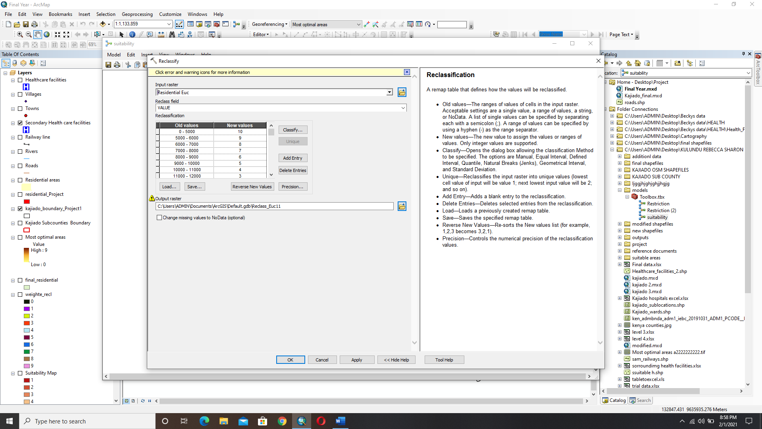For residential areas, values from 0 to 5km were given the value 10 and the other values above 5km were divides into 9 classes in descending order with 10 representing the class with the most suitable areas and 1 representing the class with the least suitable areas.

Fig. 3. 14 Image showing the reclassification of Residential areas in the Suitability model.

For Existing Health Care facilities values from 0 to 10km were given the value 10 and values above 10km were divided into nine classes in descending order with 10 representing the class with the most suitable areas and 1 representing the class with the least suitable areas.

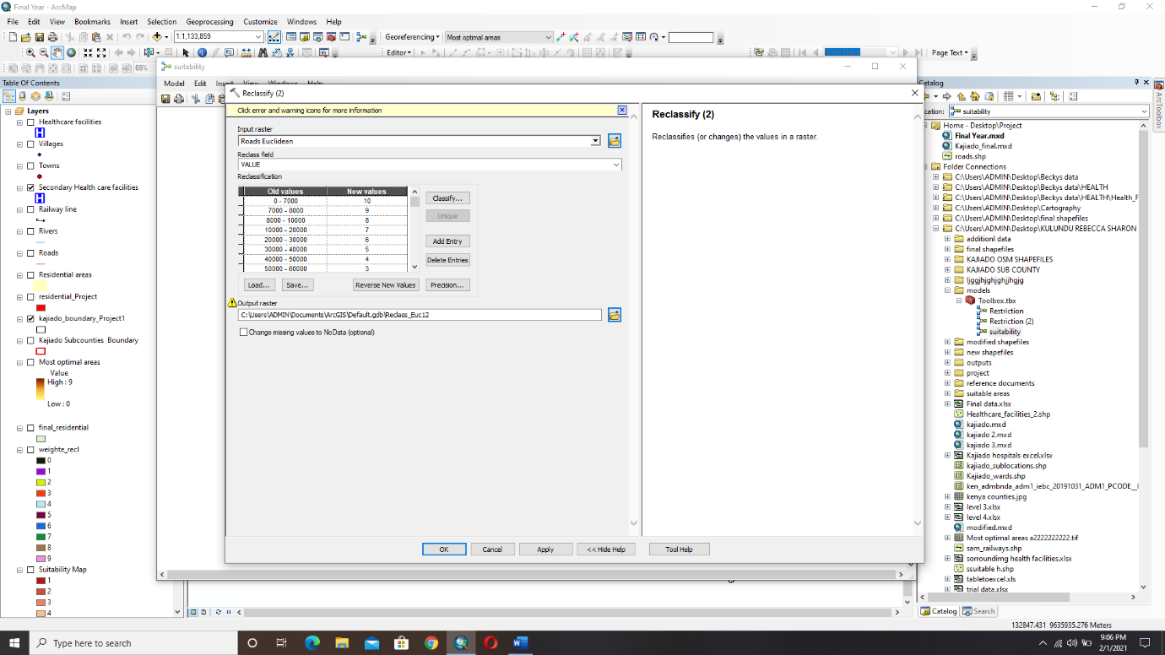Fig. 3. 15 Image showing the reclassification of Health care facilities in the Suitability model.

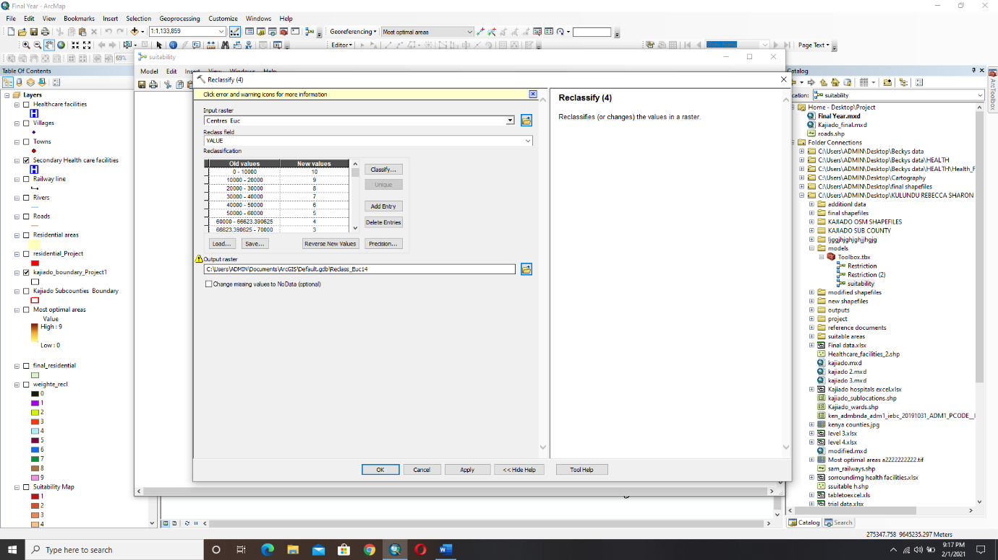For roads, values from 0 to 7km were given the value 10 and values above 7km were divided into nine classes in descending order with 10 representing the class with the most suitable areas and 1 representing the class with the least suitable areas.

Fig. 3. 16 Image showing the reclassification of Roads in the Suitability model.

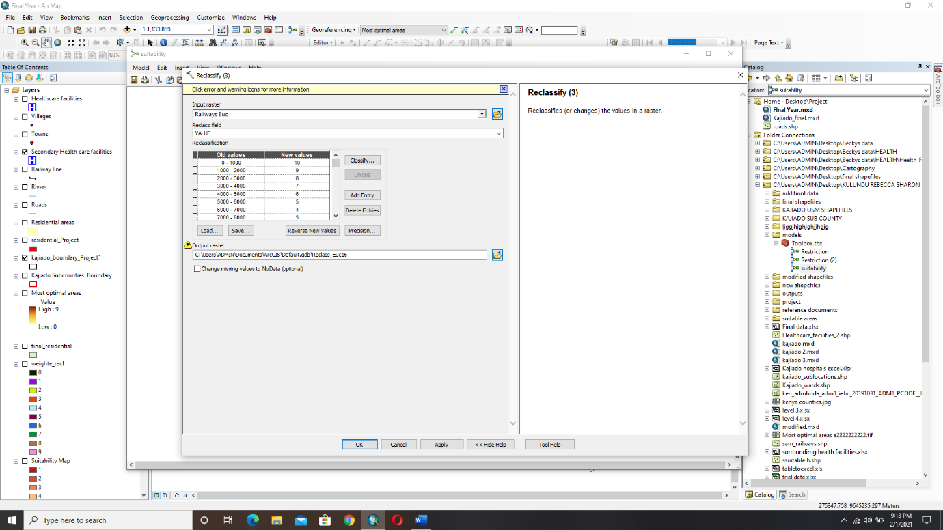For rivers values from 0 to 5.3km were given the value 10 and values above 5.3 km were divided into nine classes in descending order with 10 representing the class with the most suitable areas and 1 representing the class with the least suitable areas.

Fig. 3. 17 Image showing the reclassification of Rivers in the Suitability model.

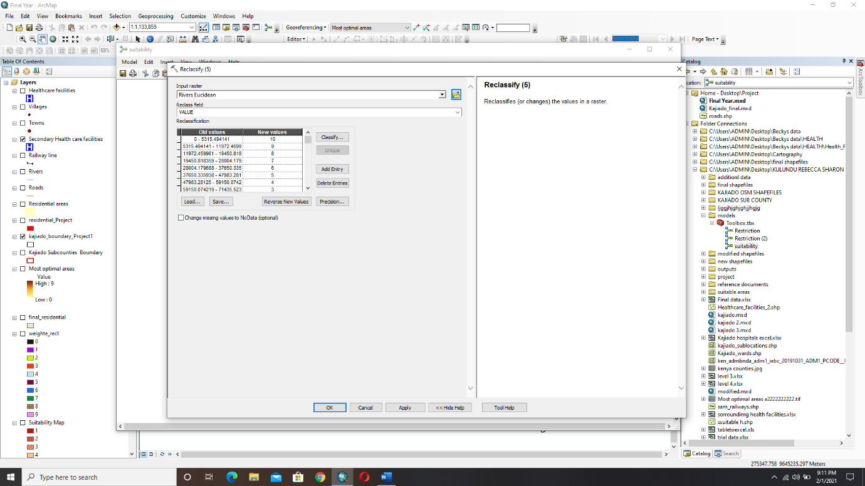For railway line values from 0 to 1km were given the value 10 and values above 1 km were divided into nine classes in descending order with 10 representing the class with the most suitable areas and 1 representing the class with the least suitable areas

Fig. 3. 18 Image showing the reclassification of Railway line in the Suitability model.

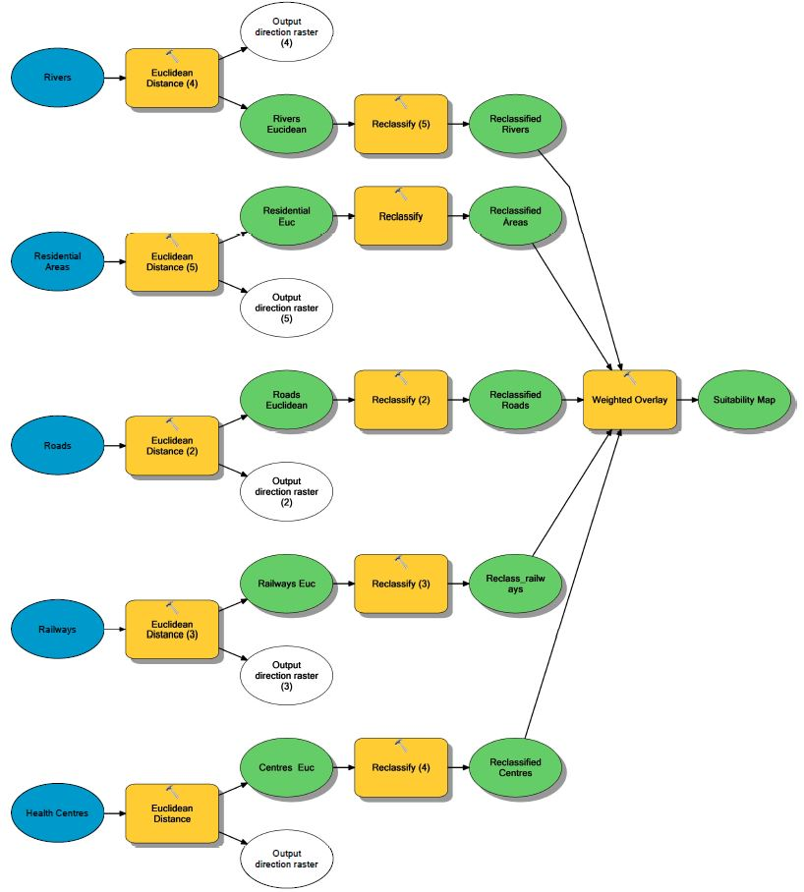

Fig. 3. 19 Image showing the suitability model

## **3.5 Weighted Overlay.**

Weighted overlay was carried out as the final step in the suitability model to overlay the raster datasets that had been reclassified and assign weights to all the criteria that had been calculated through an Analytical Hierarchy Process.

## **3.6 Raster Calculator.**

A raster calculator is a tool in ArcGIS that builds and executes a single map algebra expression using python syntax in a calculator-like interface.

The Raster Calculator was used to calculate reclassified roads x reclassified rivers x reclassified railway x healthcare centers to get the restriction map.

The Raster Calculator was used to get the most Optimal areas to locate a health facility by multiplying the Restriction map and the Suitability map.

## **3.7 Flood Analysis.**

Flood analysis was done to establish potential flood-prone areas as a health care facility should be located in an area that is free from the dangers of flooding. For this, the Kenya 30 meters SRTM elevation raster data set was used. From the data, the lowest point in Kajiado was at 573 meters above sea level and the highest at 2554 meters above sea level. From the DEM, the lowest areas in Kajiado were identified and categorized into three distinct regions from the most flood-prone areas to the least flood-prone areas. These areas are therefore not suitable for the location of a healthcare facility. The optimal areas were then overlayed with the DEM Raster dataset to generate the most optimal areas which are free from the dangers of Flooding.

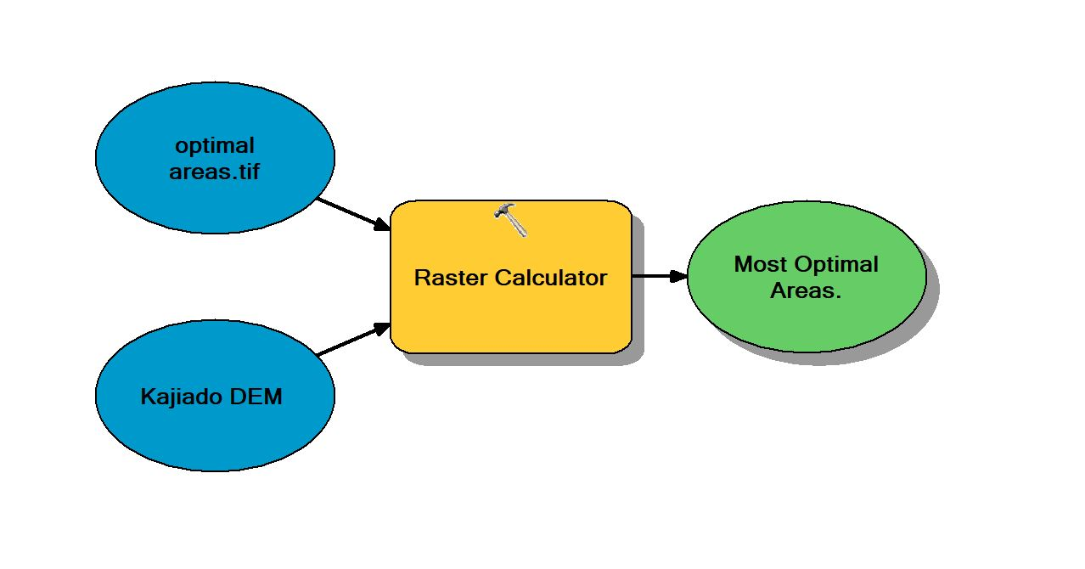

Fig. 3. 20 Image showing Kajiado DEM and Optimal areas map overlay model

# CHAPTER FOUR; RESULTS AND DISCUSSIONS

In line with the objectives, the following results were obtained.

## **4.1 Euclidean Distance Results**

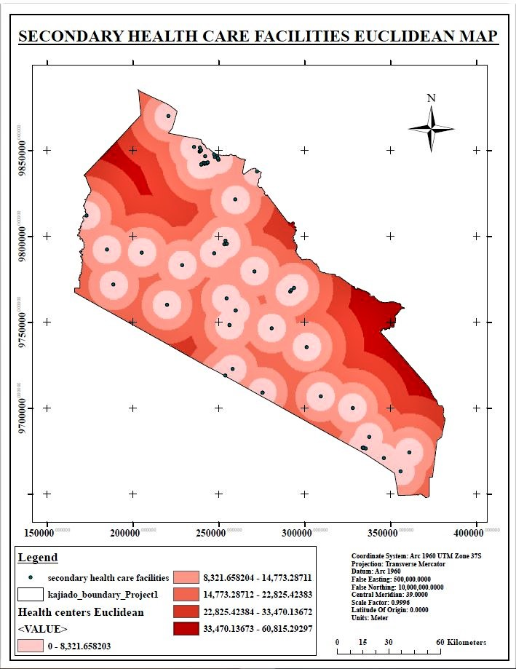Fig. 4. 1 Map showing Secondary Healthcare Facilities Euclidean map

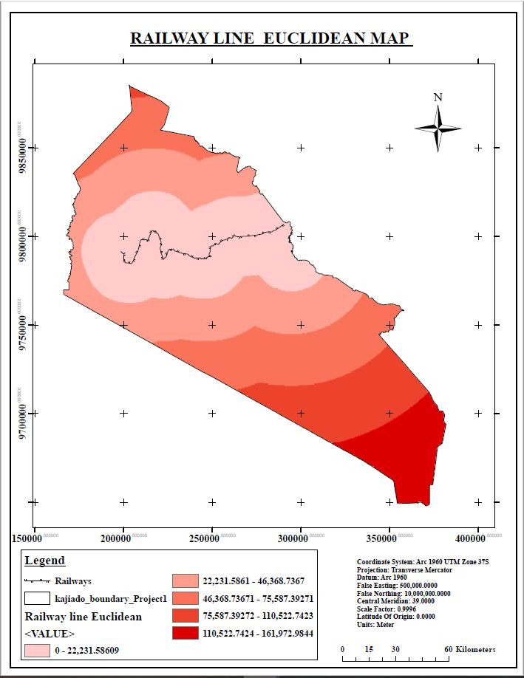

Fig. 4. 2 Map showing Railway line Euclidean map

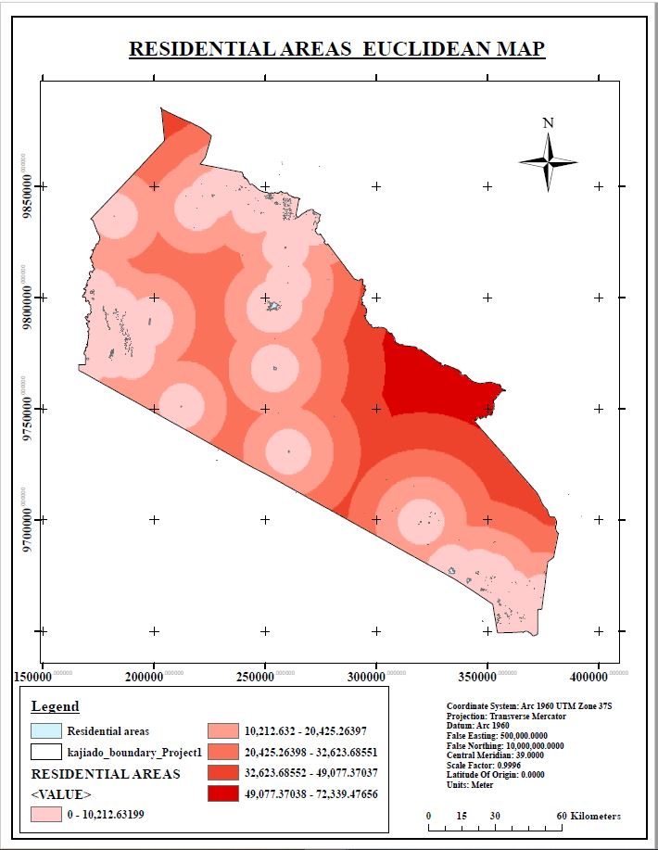Fig. 4. 3 Map showing Residential areas Euclidean map

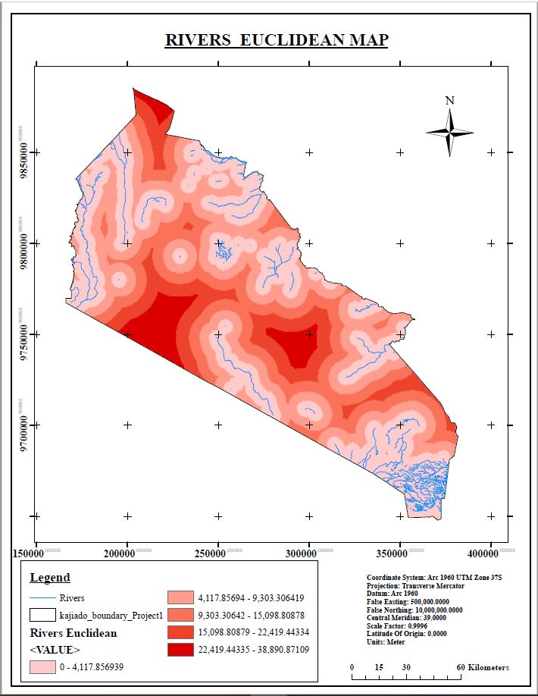Fig. 4. 4 Map showing Rivers Euclidean map

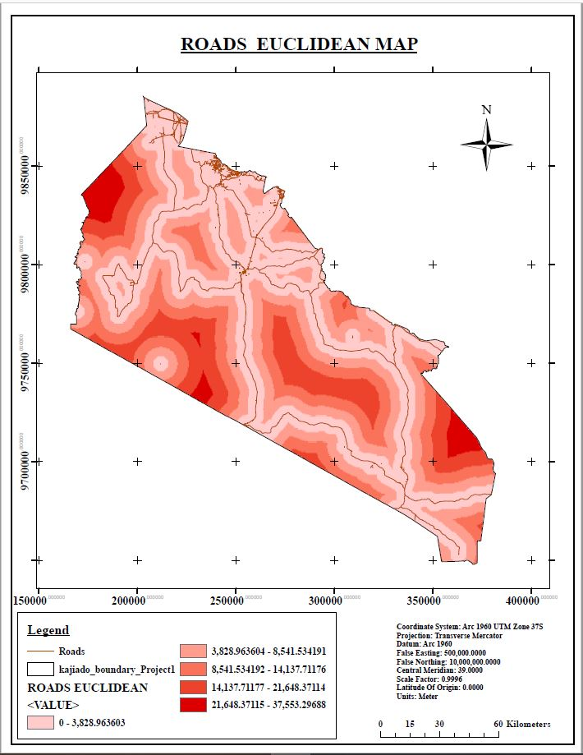

Fig. 4. 5 Map showing Roads Euclidean map

## **4.2 Restriction Processs Results**

Fig. 4. 6 Map showing Healthcare Facilities Restriction map

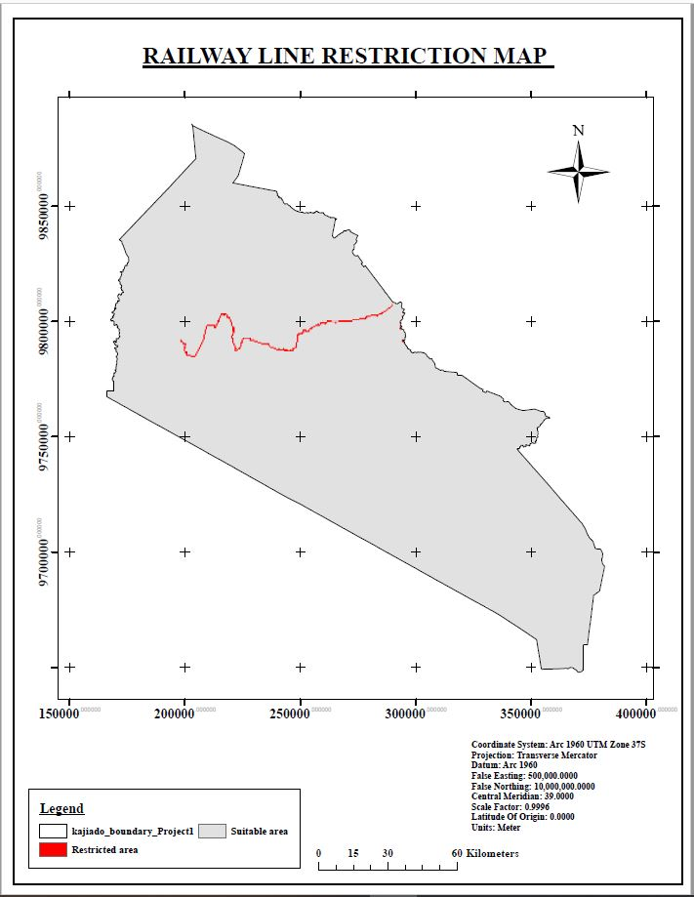

Fig. 4. 7 Map showing Railway line Restriction map

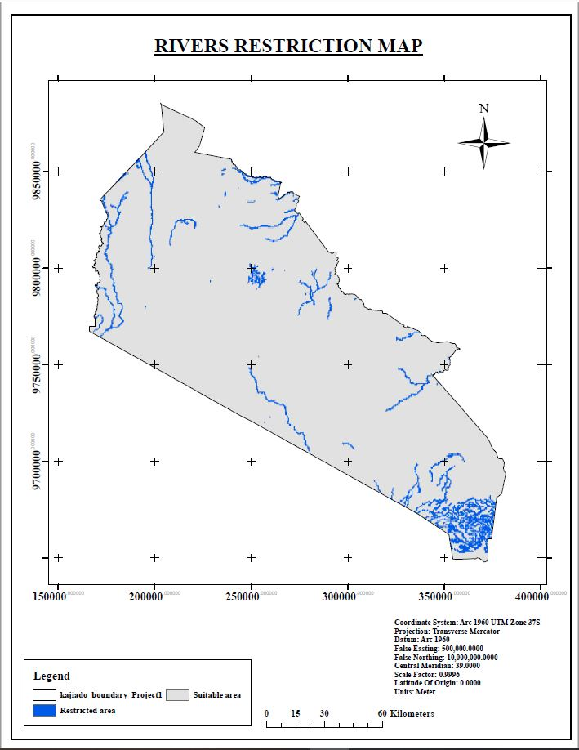Fig. 4. 8 Map showing Rivers Restriction map

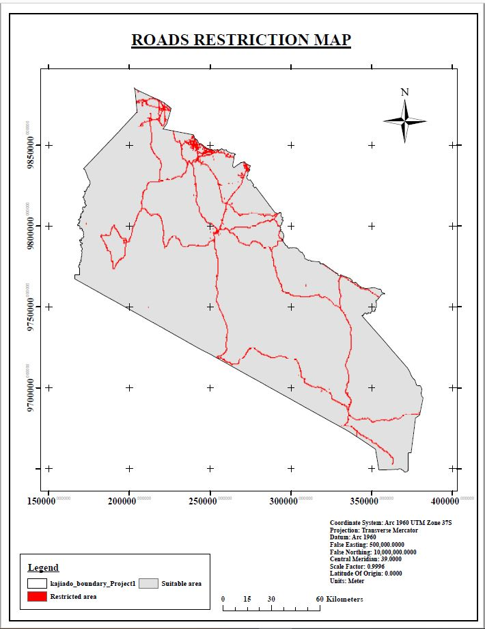Fig. 4. 9 Map showing Roads Restriction map

.

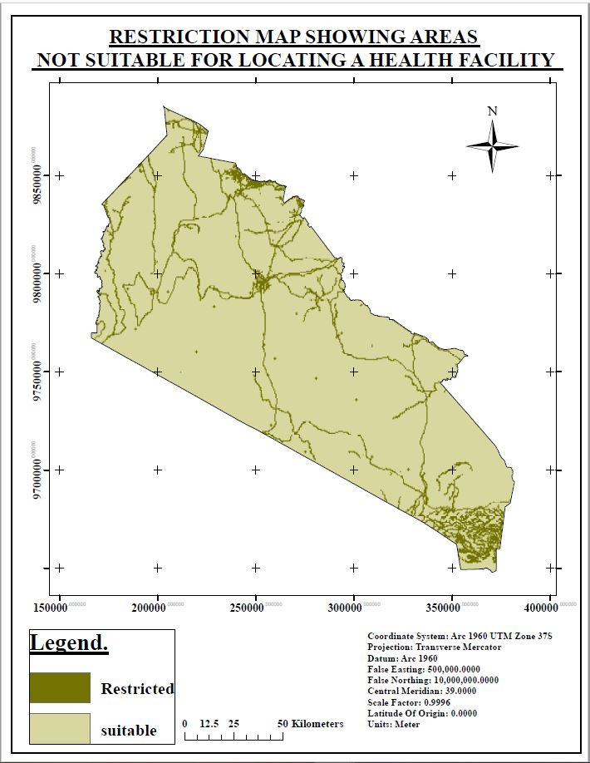Fig. 4. 10 Map showing areas not suitable for locating a health facility

## **4.3 Suitability Process Results**

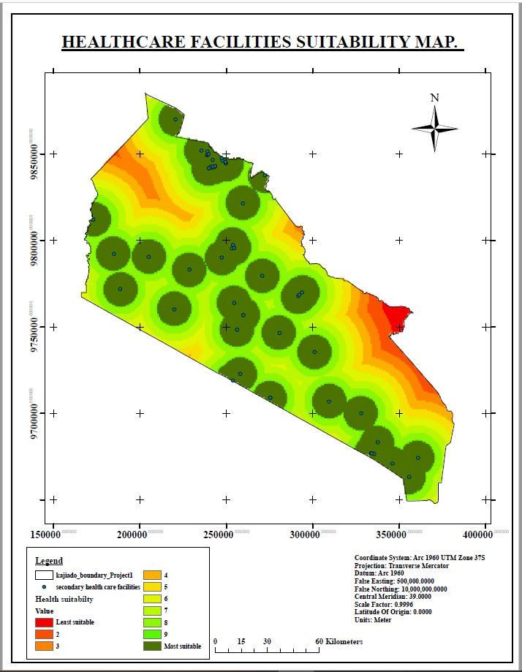

Fig. 4. 11 Map showing Healthcare Facilities Suitability map

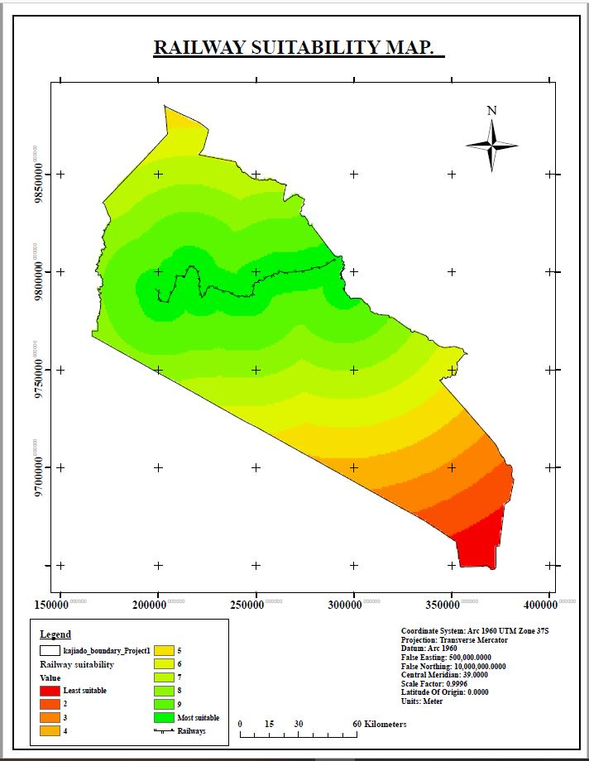

Fig. 4. 12 Map showing Railway Suitability map

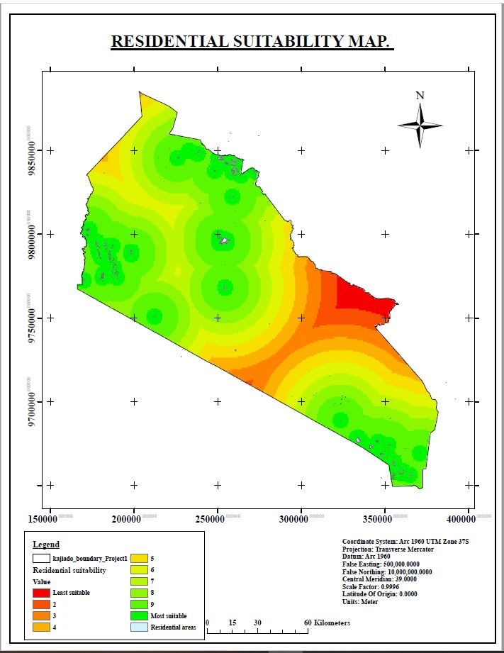

Fig. 4. 13 Map showing Residential Suitability map

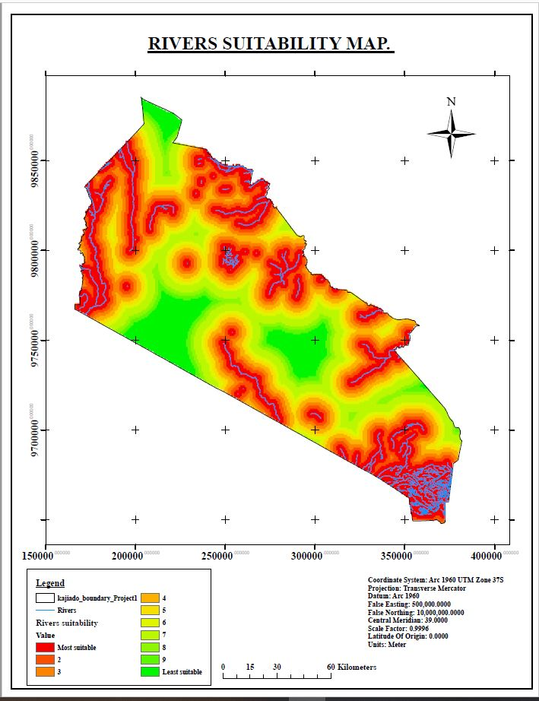

Fig. 4. 14 Map showing Rivers Suitability map

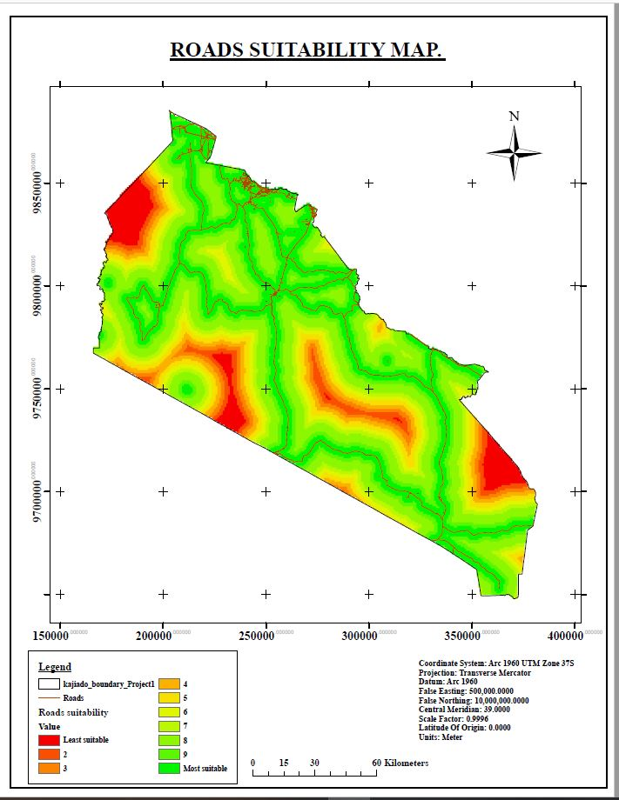

Fig. 4. 15 Map showing Roads Suitability map

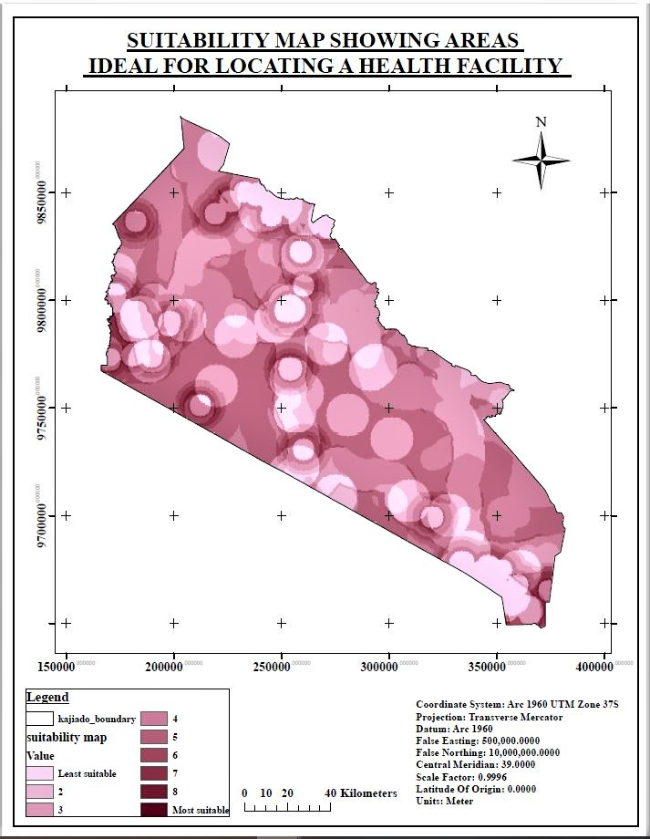Fig. 4. 16 Map showing areas ideal for locating health facilities

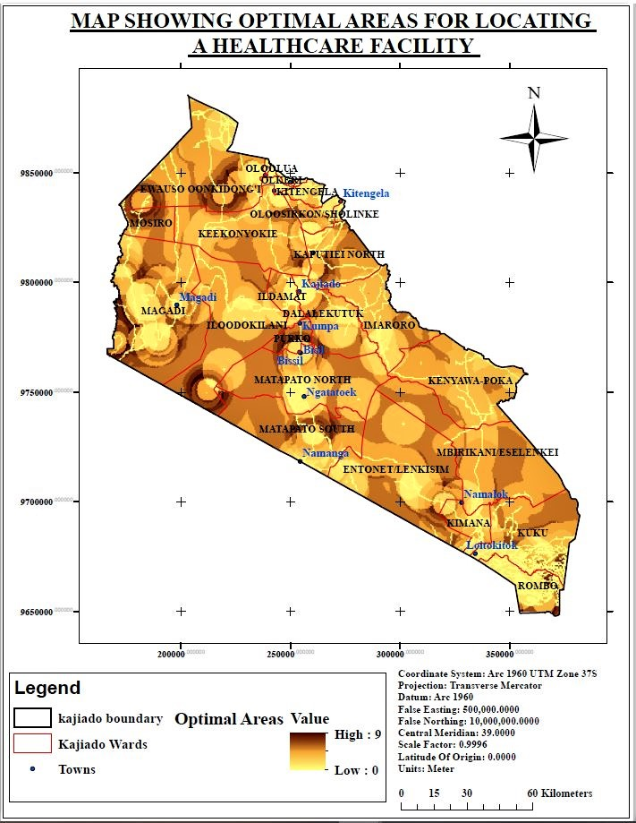

Fig. 4. 17 Map showing optimal areas for locating a health facility

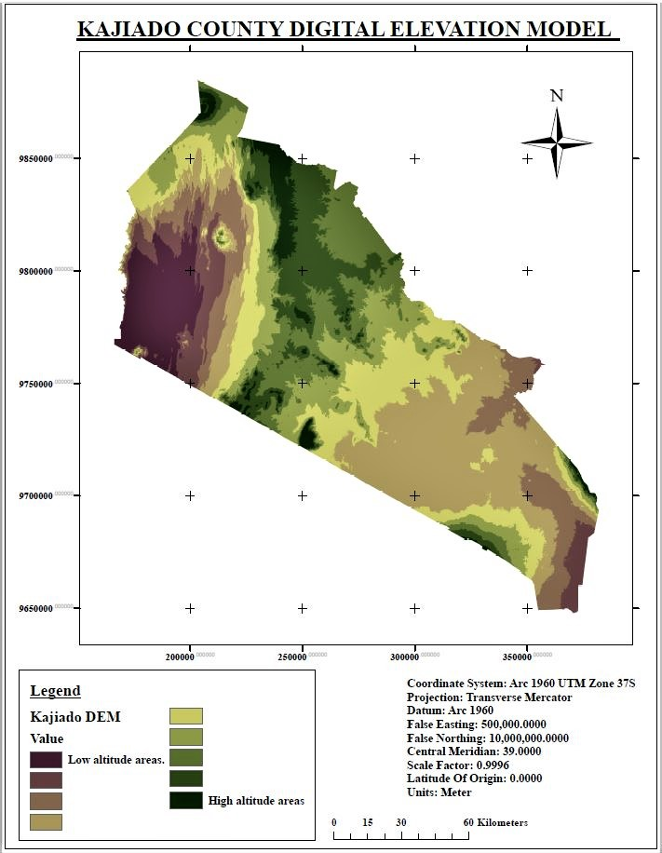

Fig. 4. 18 Map showing Kajiado County digital elevation model

Fig. 4. 19 Map showing Kajiado County flood analysis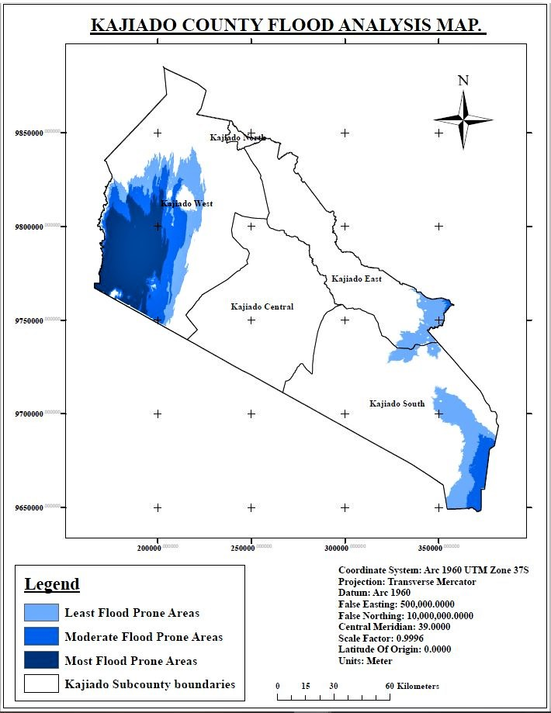

Fig. 4. 20 Map showing the most optimal areas for locating a health facility

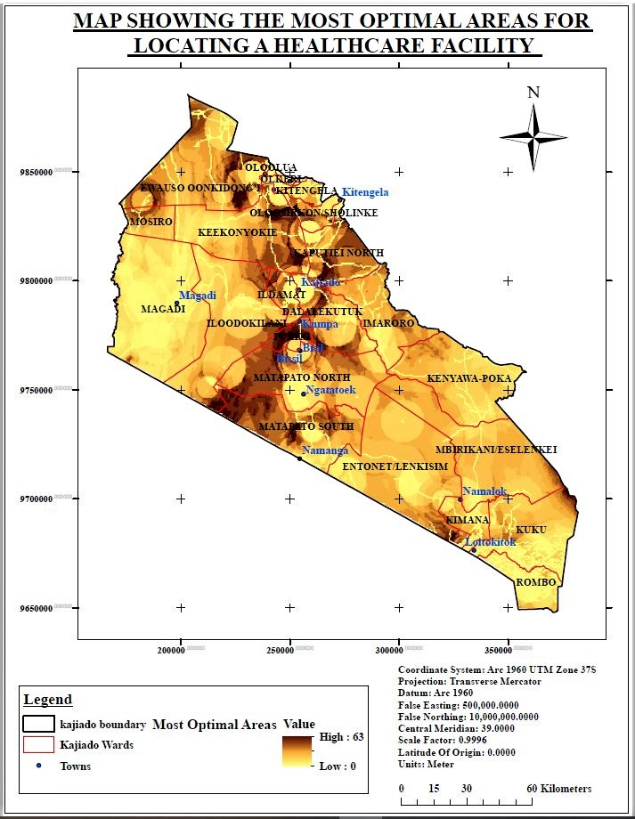

## **4.4 Discussion**

Results from the Euclidean distance operation generally shows how the vector datasets for secondary healthcare facilities, railwayline, residential areas, roads and rivers have been rasterized.

From the restriction model results, Fig. 4.6 showed restricted areas in green that are within 500m within an existing health facility where new healthcare facility cannot be located. Thus a healthcare facility can be located anywhere on the suitable area.

Fig. 4.7 showed restricted areas in red that are within 45 metres from the railway line hence not suitable for location of a healthcare facility.

Fig. 4.8 showed restricted areas in blue; are those that are within 45m from a river hence not suitable for location of a healthcare facility.

Fig. 4.9 showed restricted areas in red that are within 45 metres from the road, hence not suitable for the location of a healthcare facility.

Fig. 4.10 showed the map output for the restriction model showing areas that are restricted by the criteria from the location of a health facility.

From the suitability model results, Fig. 4.11 showed the most suitable areas within a distance of 10km from an existing healthcare facility in dark green. The suitability reduced as one moves further away from a location, that is 10km from an existing health facility.

Fig. 4.12 showed that the most suitable areas are those that are within 45 metres from the railway line. The suitability reduced as one moved further away from the 45m mark.

Fig. 4.13 showed that the most suitable areas are those that are within 5km of a residential area. The suitability reduces as one moves further away from the 5km mark.

Fig. 4.14 showed that the most suitable areas are more than 45 metres from a river. The suitability reduces as one moves further away from the 45m mark.

Fig. 4.15 showed the most suitable areas that are 45m from a major road. The suitability reduces as one moves further away from the 45m mark.

Fig. 4.16 showed the map output for the suitability model showing areas that are suitable for the location of a health facility.

Fig. 4.17 showed the map output generated from overlaying the restriction map and the suitability map using the raster calculator to generate optimal areas for locating a health facility.

Fig. 4.18 showed the map output resulting from reclassification of the Kenya SRTM 30 metres DEM to show distinctively how the terrain changes from low altitude to high altitude.

Fig. 4.19 showed the flood-prone areas in Kajiado County which are not suitable for the location of a healthcare facility.

Fig. 4.20 showed the most optimal areas for locating a healthcare facility after performing flood analysis.

Overlaying the suitability and restriction model generated the optimal areas. Performing flood analysis generated the most optimal areas for the location of healthcare facilities.

Many of those areas as shown in the final map are within the following wards; Kuku, Mosiro, Matapato North, Matapato South, Ewaso Oonkidong’i, Kaputiei North, Rurko, Ildamat, Dalalekutuk, Entonet/ Lenkisim, Mbirikani/ Eselenkei, Oloosirken sholinke and Keekonyonke which are in the North Eastern, Central and some parts of Southern Kajiado.

# CHAPTER FIVE; CONCLUSION AND RECOMMENDATIONS

## **5.1 Conclusion.**

The main objective of the study was to use geospatial technology to determine suitable sites for setting up health facilities in Kajiado County. It was achieved through the identification of factors that influence the location of a health facility. Generation of digital maps depicting the various criteria for the location of a health facility and finally perform a multi-criteria analysis using the criteria that influence the location of a health facility to determine the most optimal areas for the location of a new health facility.

The criteria for the identification of a health facility are per WHO guidelines. The generation of the digital maps depicting the various criteria has been carried out through performing Euclidean distance and reclassification on the data.. Multi-criteria analysis was carried outs and resulted in the generation of the most optimal areas which are also free from flooding.

The study revealed that there were 60 existing secondary health care facilities (47 level 3 and 13 level 4). Also the new optimal areas for the location of the healthcare facilities are within the following wards; Kuku, Mosiro, Matapato North, Matapato South, Ewaso Oonkidong’i, Kaputiei North, Rurko, Ildamat, Dalalekutuk, Entonet/ Lenkisim, Mbirikani/ Eselenkei, Oloosirken sholinke and Keekonyonke which are in the North Eastern, Central and some parts of Southern Kajiado.

It can be concluded that the study has effectively showcased the capability of geospatial technology, GIS to be specific, as an accurate tool in a decision support system in the selection of suitable areas for setting up health facilities in the county.

## **Recommendations.**

From the study, it’s recommended that Geospatial technology such as GIS be applied in a decision support system for the selection of suitable sites for location of health care facilities in other counties and the rest of the country.

Also, the results of the study be used by health policymakers in Kajiado County for determination of the suitable areas for locating a healthcare facility to improve access to healthcare and reduce inequality in the coverage,curb unplanned growth of healthcare facilities and prevent wastage of resources.

Further study can be carried out on the applicability of GIS for the determination of suitable sites for the location of healthcare facilities in the region and globally.

# 

# CHAPTER SIX: REFERENCES

Citizen Tv, K. (2020, January 26). *Mother jumps off moving vehicle after child's death*. Retrieved from https://youtu.be/a-5cA-LFWW0

Citizen TV, K. (2020, January 31). *Woman falls from an ambulance and dies.* Retrieved from https://youtu.be/CaNRdnVPEu8

Fadahunsi, J. a. (2017). *Spatial Analysis of Distribution Patterns of Healthcare Facilities in Osun State, Nigeria .* Nigeria.

Fine, P. P. (2013). *John Snow's Legacy:Epidemiology without borders.*

Kavuwa, S. M. (2010). *APPLICATION OF A WEB-GIS AS A TOL IN HMIS.* Nairobi.

Keenan, P. (1997). *Using a GIS as a DSS Genarator.*

Kenya., E. A. (2019, April 3). Retrieved from ArcGIS Hub: https://hub.arcgis.com/datasets/6ada9cfb67114d67977a266875800994_0

Mariita, A. (2019). Kenyas health structure and the six levels of hospitals.

Marindany, K. (2019, December 28). *FLOODED PLAINS*. Retrieved from The Star: https://www.the-star.co.ke/counties/rift-valley/2019-12-28-more-than-300-people-displace-as-floods-cause-havoc-in-kajiado/

Masi, R. (2019, November 25). Retrieved from CITIZEN Digital: https://citizentv.co.ke/news/five-family-members-killed-after-their-vehicle-swept-by-floods-305220/

Mrs P.C. Luis, D. Y. (1996). *DISTIRCT HOSPITALS:GUIDELINES FOR DEVELOPMENT second edition.*

Njoku, E. A. (2013). *. Locational Efficiency of Healthcare Facilities in Ikot Ekpene Local Government of Akwa-Ibom State: The Role of Geographical information System (GIS).* Nigeria.

NTV, K. (2017, February 16). *Accident victims turned away from private hospital in Kajiado*. Retrieved from https://youtu.be/QbeLqiIKAxY

Shambhu Acharya, V. L. (2018). The role of health in achieving the sustainable development goals.

Shamshi, S. U. (2012). *GIS Applications in Floodplain Management.*

Statistics, K. N. (2019). *KENYA POPULATION AND HOUSING CENSUS.* Nairobi.

Technology, P. (2014). *What Is The Analytic Hierarchy Process (AHP)?* Retrieved from Passage Technology: passagetechnology.com/what-is-the-analytic-hierarchy-process#:~:text=The%20Analytic%20Hierarchy%20Process,was%20developed%20by%20Thomas%20L.&text=AHP%20provides%20a%20rational%20framework,elements%20to%20the%20overall%20goal.